HTML Table Elements

📘 Definition
# Source: AI Source: Provided by: [Data Path: Persons Table -> ID Column: 1, Name_En Column: Motasem Essam] -> From: [ChatGPT] on [5/6/2026]
HTML tables are used to organize and display data in rows and columns.
Tables are commonly used for:
- schedules
- reports
- product lists
- statistics
- structured information

🧠 Main Table Elements
# Source: AI Source: Provided by: [Data Path: Persons Table -> ID Column: 1, Name_En Column: Motasem Essam] -> From: [ChatGPT] on [5/6/2026]
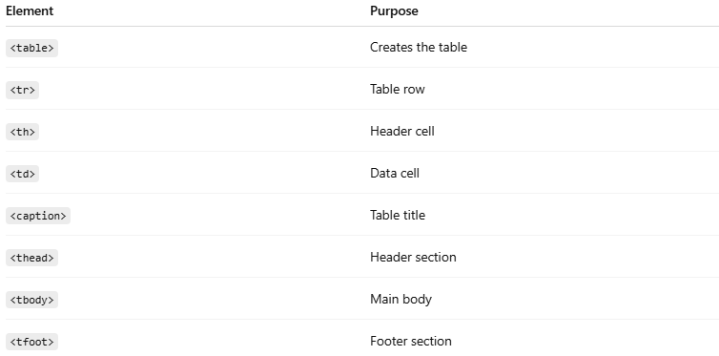
Element | Purpose
<table> | Creates the table
<tr> | Table row
<th> | Header cell
<td> | Data cell
<caption> | Table title
<thead> | Header section
<tbody> | Main body
<tfoot> | Footer section

🌐 Basic Table Example
# Source: AI Source: Provided by: [Data Path: Persons Table -> ID Column: 1, Name_En Column: Motasem Essam] -> From: [ChatGPT] on [5/6/2026]
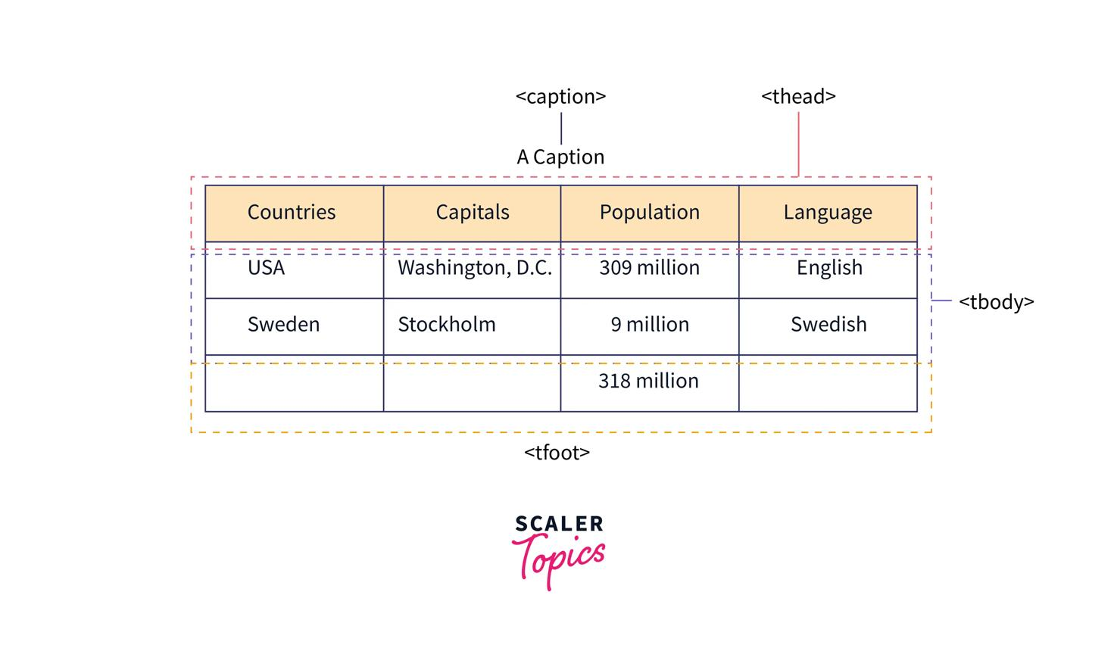
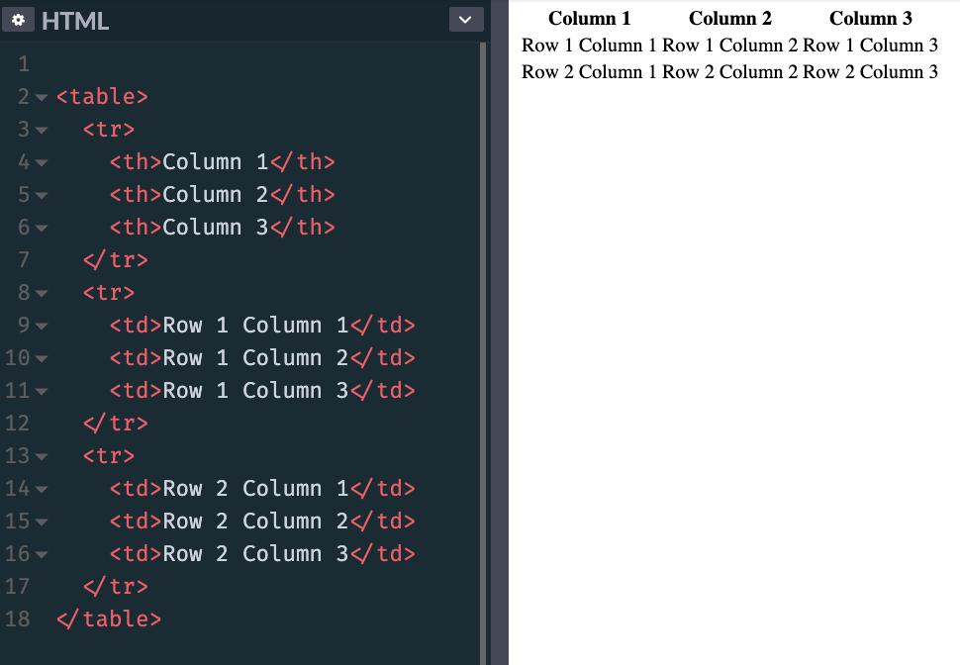
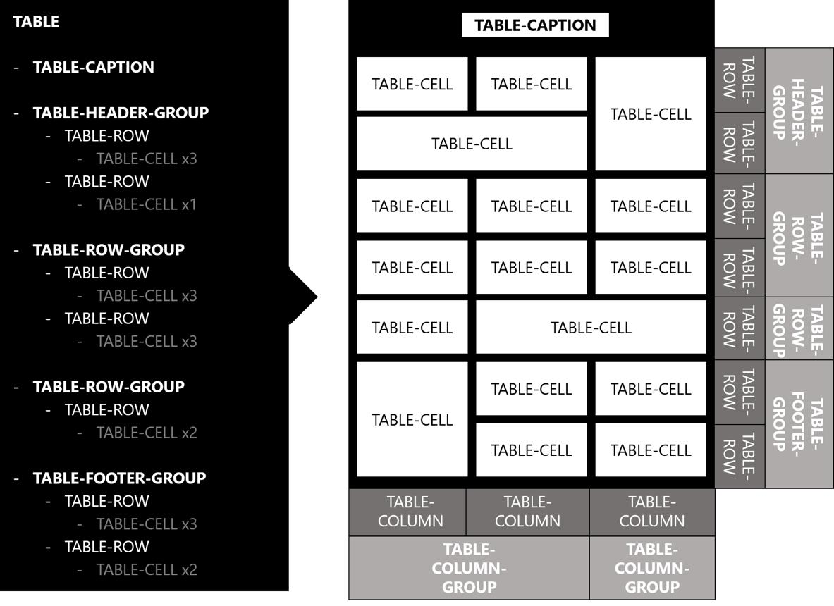
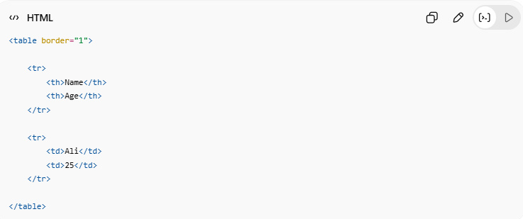
<table border="1">
<tr>
<th>Name</th>
<th>Age</th>
</tr>
<tr>
<td>Ali</td>
<td>25</td>
</tr>
</table>
👉 Displays data in rows and columns

🔤 Common Table Elements

1. 📋 <table>
# Source: AI Source: Provided by: [Data Path: Persons Table -> ID Column: 1, Name_En Column: Motasem Essam] -> From: [ChatGPT] on [5/6/2026]
📖 Description
Main container for the table.
💻 Example:
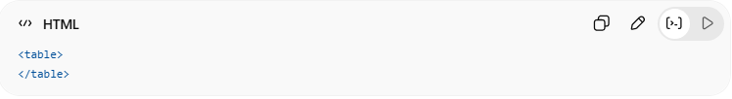
<table>
</table>

2. 📄 <tr> (Table Row)
# Source: AI Source: Provided by: [Data Path: Persons Table -> ID Column: 1, Name_En Column: Motasem Essam] -> From: [ChatGPT] on [5/6/2026]
📖 Description
Creates a row inside the table.
💻 Example:
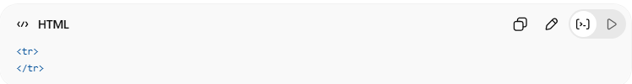
<tr>
</tr>

3. 🔠 <th> (Table Header)
# Source: AI Source: Provided by: [Data Path: Persons Table -> ID Column: 1, Name_En Column: Motasem Essam] -> From: [ChatGPT] on [5/6/2026]
📖 Description
Defines a header cell.
👉 Usually bold and centered
💻 Example:
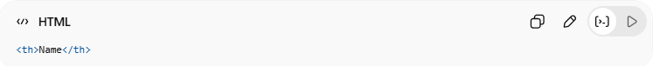
<th>Name</th>

4. 🧾 <td> (Table Data)
# Source: AI Source: Provided by: [Data Path: Persons Table -> ID Column: 1, Name_En Column: Motasem Essam] -> From: [ChatGPT] on [5/6/2026]
📖 Description
Defines a normal data cell.
💻 Example:
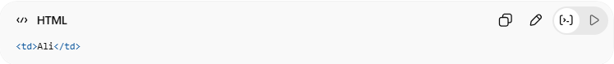
<td>Ali</td>

5. 🏷️ <caption>
# Source: AI Source: Provided by: [Data Path: Persons Table -> ID Column: 1, Name_En Column: Motasem Essam] -> From: [ChatGPT] on [5/6/2026]
📖 Description
Adds a title to the table.
💻 Example:
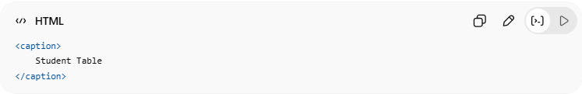
<caption>
Student Table
</caption>

6. 🧩 <thead>
# Source: AI Source: Provided by: [Data Path: Persons Table -> ID Column: 1, Name_En Column: Motasem Essam] -> From: [ChatGPT] on [5/6/2026]
📖 Description
Groups table header content.
💻 Example:
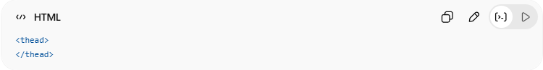
<thead>
</thead>

7. 📦 <tbody>
# Source: AI Source: Provided by: [Data Path: Persons Table -> ID Column: 1, Name_En Column: Motasem Essam] -> From: [ChatGPT] on [5/6/2026]
📖 Description
Groups main table data.
💻 Example:
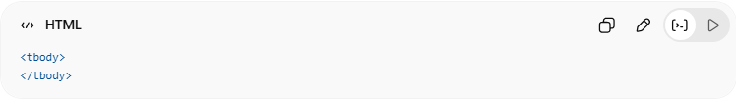
<tbody>
</tbody>

8. 📌 <tfoot>
# Source: AI Source: Provided by: [Data Path: Persons Table -> ID Column: 1, Name_En Column: Motasem Essam] -> From: [ChatGPT] on [5/6/2026]
📖 Description
Groups footer content.
💻 Example:
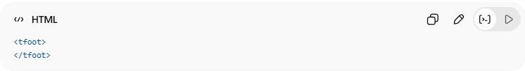
<tfoot>
</tfoot>

💻 Example

Full Example
# Source: AI Source: Provided by: [Data Path: Persons Table -> ID Column: 1, Name_En Column: Motasem Essam] -> From: [ChatGPT] on [5/6/2026]
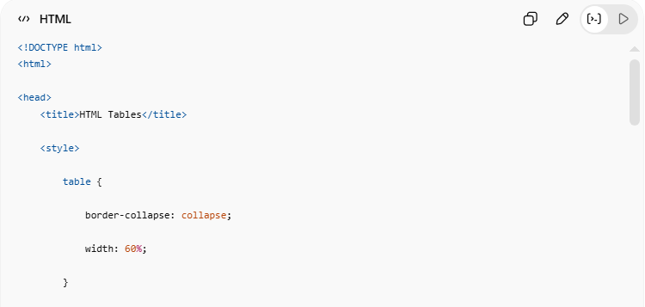
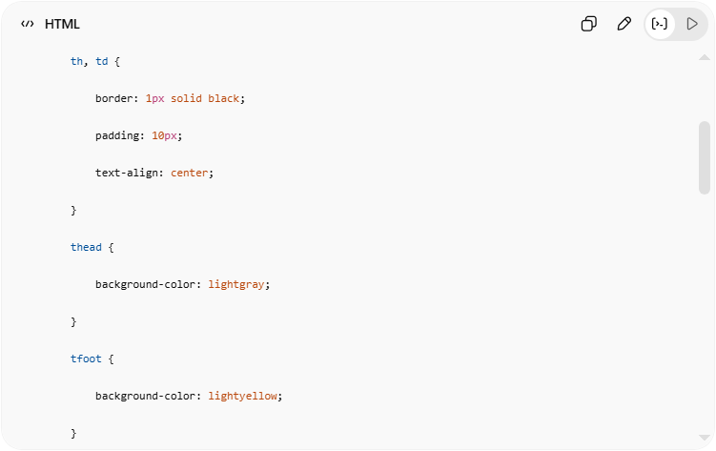
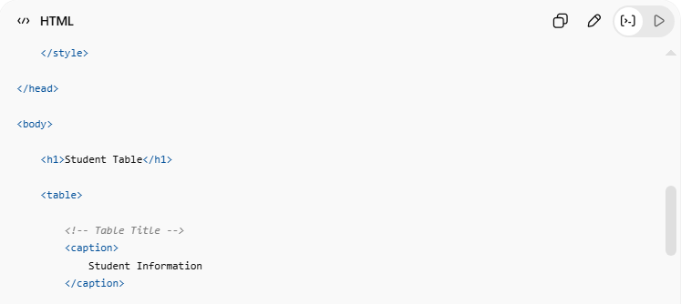
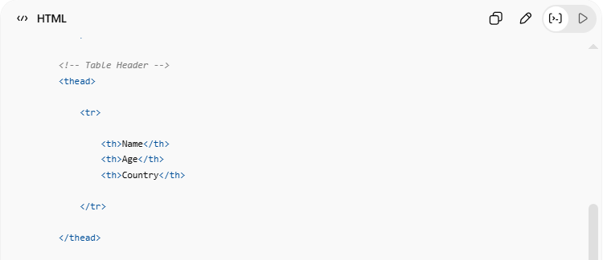
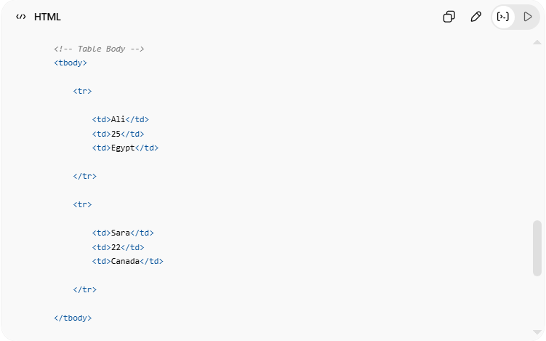

<!DOCTYPE html>
<html>
<head>
<title>HTML Tables</title>
<style>
table {
border-collapse: collapse;
width: 60%;
}
th, td {
border: 1px solid black;
padding: 10px;
text-align: center;
}
thead {
background-color: lightgray;
}
tfoot {
background-color: lightyellow;
}
</style>
</head>
<body>
<h1>Student Table</h1>
<table>
<!-- Table Title -->
<caption>
Student Information
</caption>
<!-- Table Header -->
<thead>
<tr>
<th>Name</th>
<th>Age</th>
<th>Country</th>
</tr>
</thead>
<!-- Table Body -->
<tbody>
<tr>
<td>Ali</td>
<td>25</td>
<td>Egypt</td>
</tr>
<tr>
<td>Sara</td>
<td>22</td>
<td>Canada</td>
</tr>
</tbody>
<!-- Table Footer -->
<tfoot>
<tr>
<td colspan="3">
End of Table
</td>
</tr>
</tfoot>
</table>
</body>
</html>

Real Example
# Source: ScreenShot Source: Provided by: [Persons Table -> ID Column: 1, Name_En Column: Motasem Essam] -> Tool: [Automation Table -> ID Column: 16, Name_En Column: Screen Capture] -> From [Operating System: Windows] on [5/6/2026]
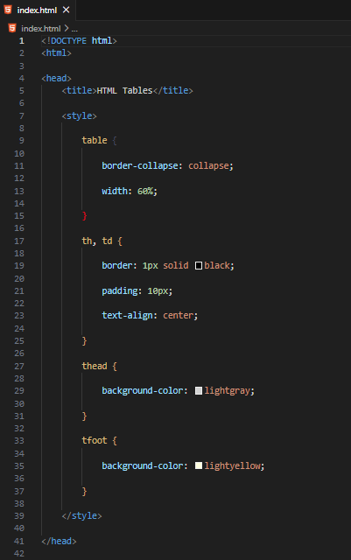
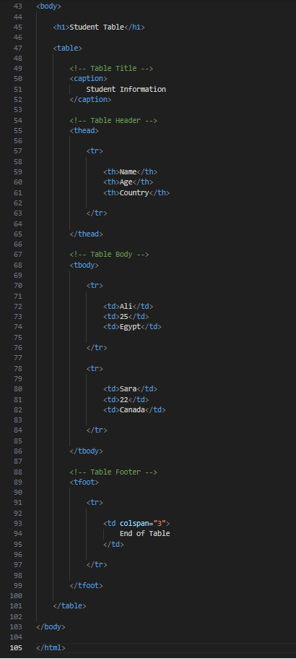
<!DOCTYPE html>
<html>

<head>
<title>HTML Tables</title>

<style>

table {

border-collapse: collapse;

width: 60%;

}

th, td {

border: 1px solid black;

padding: 10px;

text-align: center;

}

thead {

background-color: lightgray;

}

tfoot {

background-color: lightyellow;

}

</style>

</head>

<body>

<h1>Student Table</h1>

<table>

<!-- Table Title -->
<caption>
Student Information
</caption>

<!-- Table Header -->
<thead>

<tr>

<th>Name</th>
<th>Age</th>
<th>Country</th>

</tr>

</thead>

<!-- Table Body -->
<tbody>

<tr>

<td>Ali</td>
<td>25</td>
<td>Egypt</td>

</tr>

<tr>

<td>Sara</td>
<td>22</td>
<td>Canada</td>

</tr>

</tbody>

<!-- Table Footer -->
<tfoot>

<tr>

<td colspan="3">
End of Table
</td>

</tr>

</tfoot>

</table>

</body>

</html>
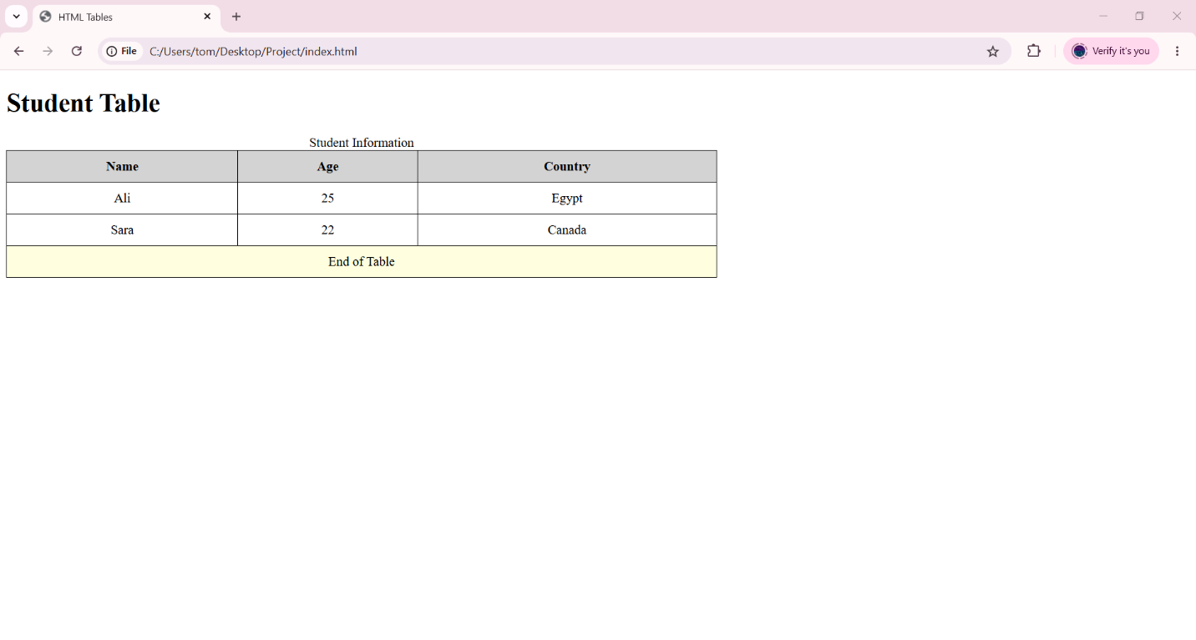

🧪 What You Can Test
# Source: AI Source: Provided by: [Data Path: Persons Table -> ID Column: 1, Name_En Column: Motasem Essam] -> From: [ChatGPT] on [5/6/2026]

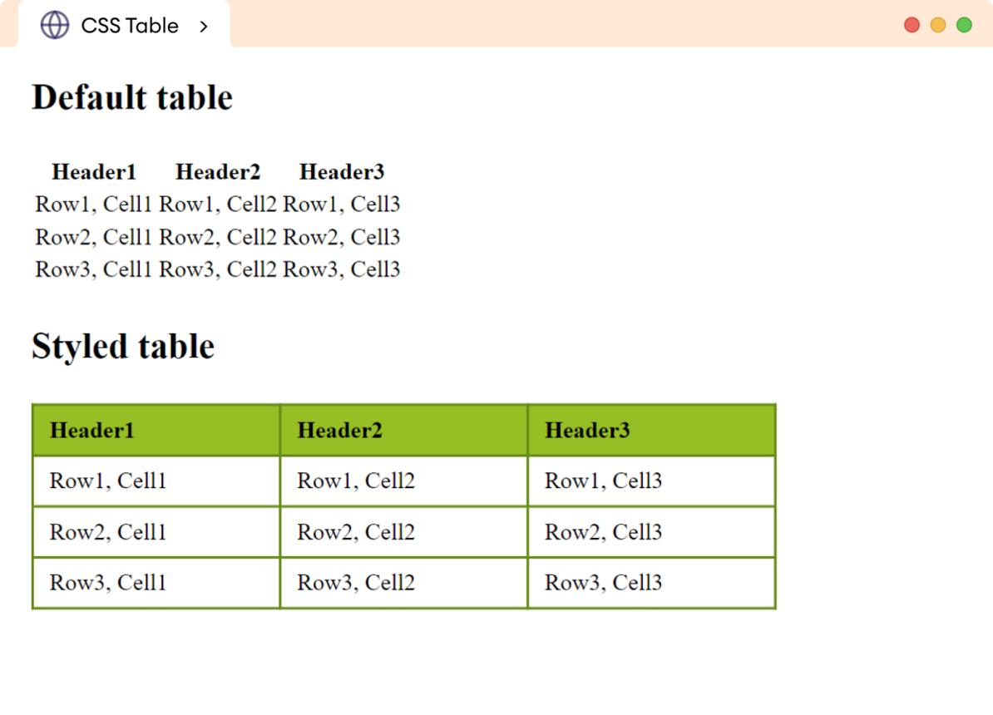
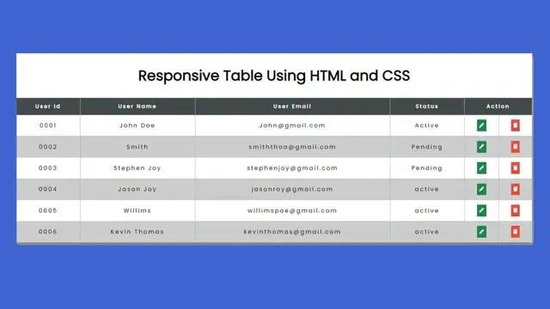
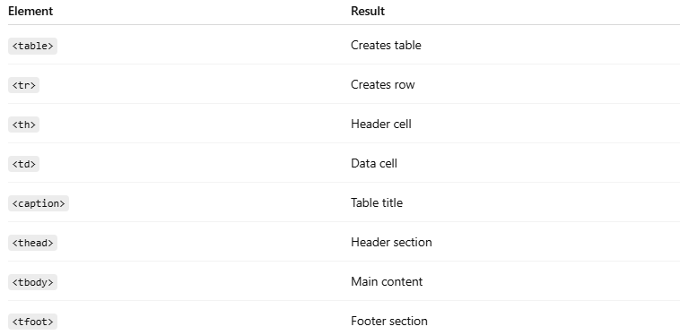
Element | Result
<table> | Creates table
<tr> | Creates row
<th> | Header cell
<td> | Data cell
<caption> | Table title
<thead> | Header section
<tbody> | Main content
<tfoot> | Footer section

HTML Table Borders

📊 HTML Table Borders
# Source: AI Source: Provided by: [Data Path: Persons Table -> ID Column: 1, Name_En Column: Motasem Essam] -> From: [ChatGPT] on [5/6/2026]
HTML table borders are styled using CSS to control border size, style, color, and border merging behavior.
Table borders are used to display lines around:
- tables
- rows
- cells
Borders are usually styled using CSS.

🌐 Basic Table Border
# Source: AI Source: Provided by: [Data Path: Persons Table -> ID Column: 1, Name_En Column: Motasem Essam] -> From: [ChatGPT] on [5/6/2026]
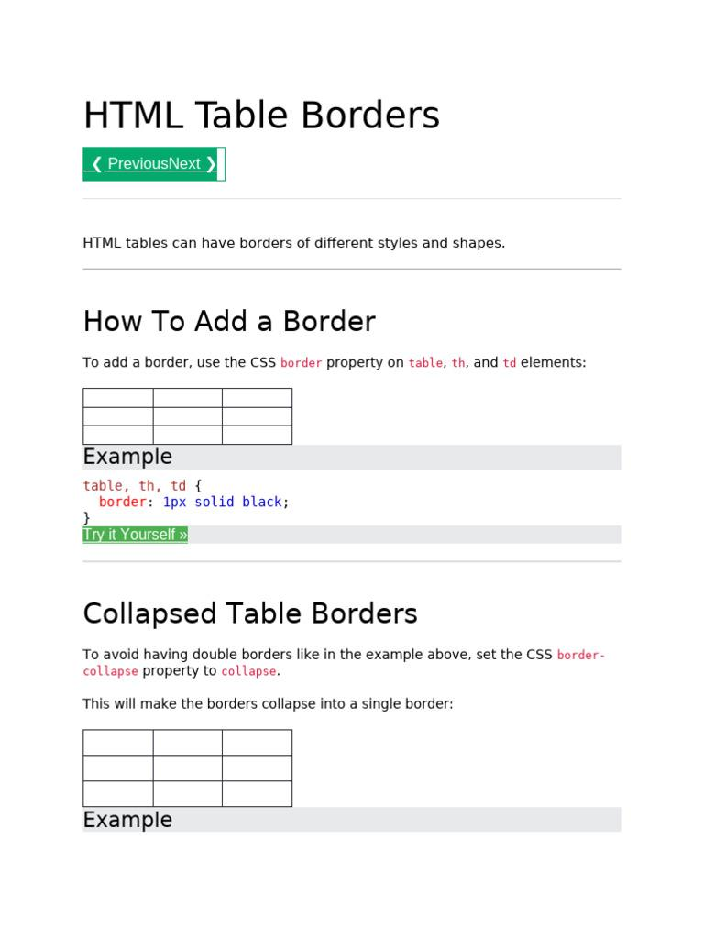
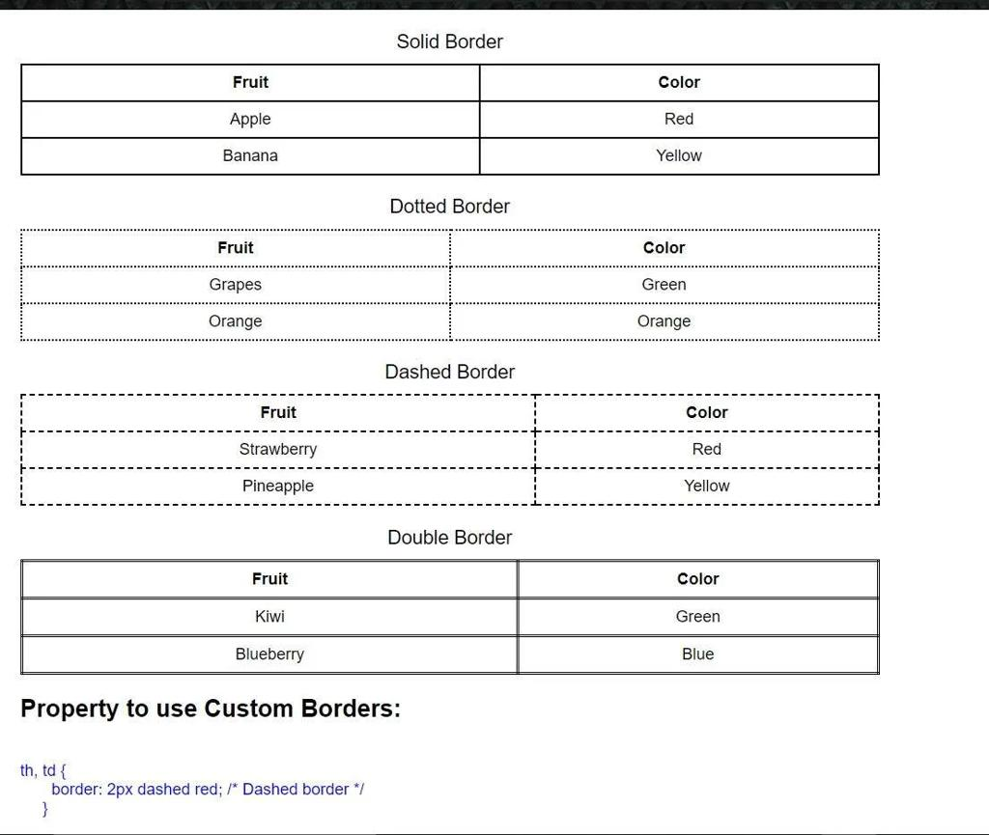
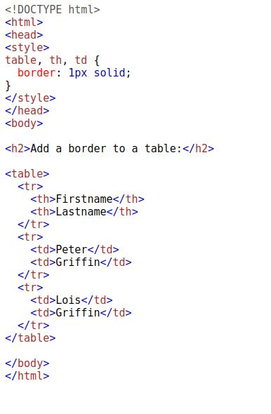
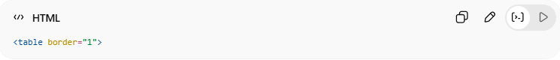
<table border="1">
👉 Adds a simple table border
⚠️ Old method (HTML attribute)

✅ Modern Method (CSS)
# Source: AI Source: Provided by: [Data Path: Persons Table -> ID Column: 1, Name_En Column: Motasem Essam] -> From: [ChatGPT] on [5/6/2026]
📖 Description
CSS is the recommended way to style table borders.
💻 Example:
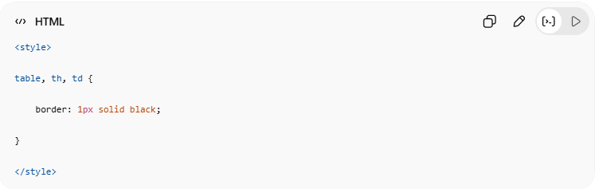
<style>
table, th, td {
border: 1px solid black;
}
</style>

🔤 Common Border Styles
# Source: AI Source: Provided by: [Data Path: Persons Table -> ID Column: 1, Name_En Column: Motasem Essam] -> From: [ChatGPT] on [5/6/2026]
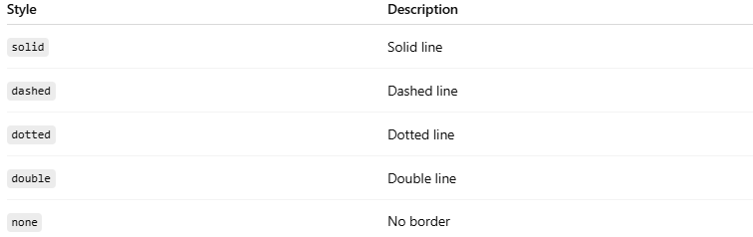
Style | Description
solid | Solid line
dashed | Dashed line
dotted | Dotted line
double | Double line
none | No border

1. ⬛ Solid Border
# Source: AI Source: Provided by: [Data Path: Persons Table -> ID Column: 1, Name_En Column: Motasem Essam] -> From: [ChatGPT] on [5/6/2026]
💻 Example:
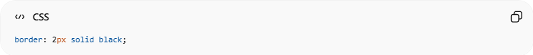
border: 2px solid black;

2. - - Dashed Border
# Source: AI Source: Provided by: [Data Path: Persons Table -> ID Column: 1, Name_En Column: Motasem Essam] -> From: [ChatGPT] on [5/6/2026]
💻 Example:

border: 2px dashed black;

3. ⚫ Dotted Border
# Source: AI Source: Provided by: [Data Path: Persons Table -> ID Column: 1, Name_En Column: Motasem Essam] -> From: [ChatGPT] on [5/6/2026]
💻 Example:
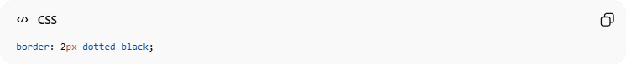
border: 2px dotted black;

4. ═ Double Border
# Source: AI Source: Provided by: [Data Path: Persons Table -> ID Column: 1, Name_En Column: Motasem Essam] -> From: [ChatGPT] on [5/6/2026]
💻 Example:
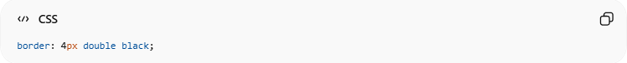
border: 4px double black;

5. ❌ No Border
# Source: AI Source: Provided by: [Data Path: Persons Table -> ID Column: 1, Name_En Column: Motasem Essam] -> From: [ChatGPT] on [5/6/2026]
💻 Example:
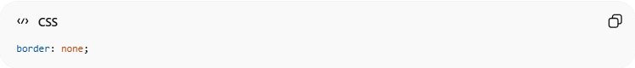
border: none;

6. 🔵 Round Table Borders
# Source: AI Source: Provided by: [Data Path: Persons Table -> ID Column: 1, Name_En Column: Motasem Essam] -> From: [ChatGPT] on [5/6/2026]
📖 Description
You can create rounded table borders using the CSS border-radius property.
👉 Makes table corners rounded instead of sharp.

💻 Example:
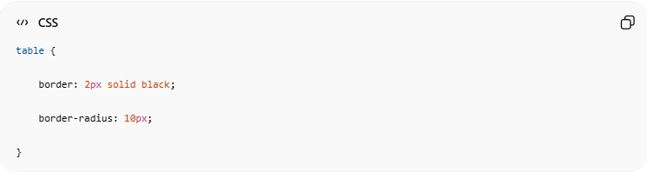
table {
border: 2px solid black;
border-radius: 10px;
}

7. 🎨 border-color
# Source: AI Source: Provided by: [Data Path: Persons Table -> ID Column: 1, Name_En Column: Motasem Essam] -> From: [ChatGPT] on [5/6/2026]
📖 Description
The border-color property changes the border color.
👉 Works with tables, rows, and cells.

💻 Example:
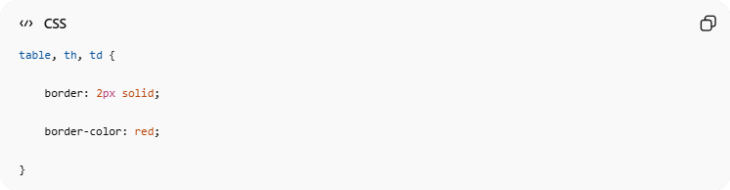
table, th, td {
border: 2px solid;
border-color: red;
}

🧩 border-collapse
# Source: AI Source: Provided by: [Data Path: Persons Table -> ID Column: 1, Name_En Column: Motasem Essam] -> From: [ChatGPT] on [5/6/2026]
📖 Description
Controls whether borders are separated or merged.

❌ Separate Borders (Default)
# Source: AI Source: Provided by: [Data Path: Persons Table -> ID Column: 1, Name_En Column: Motasem Essam] -> From: [ChatGPT] on [5/6/2026]
💻 Example:

border-collapse: separate;
👉 Borders appear separated

✅ Collapse Borders
# Source: AI Source: Provided by: [Data Path: Persons Table -> ID Column: 1, Name_En Column: Motasem Essam] -> From: [ChatGPT] on [5/6/2026]
💻 Example:
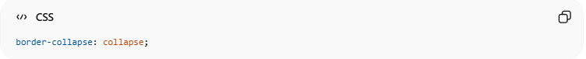
border-collapse: collapse;
👉 Borders merge into single lines

💻 Example

Full Example
# Source: AI Source: Provided by: [Data Path: Persons Table -> ID Column: 1, Name_En Column: Motasem Essam] -> From: [ChatGPT] on [5/6/2026]
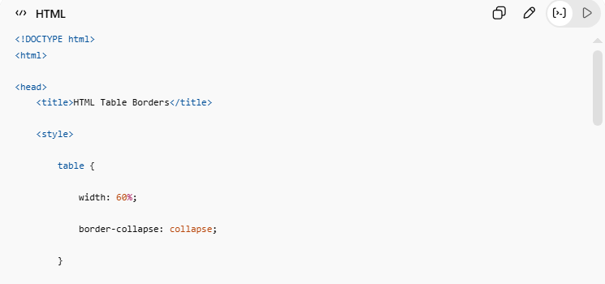
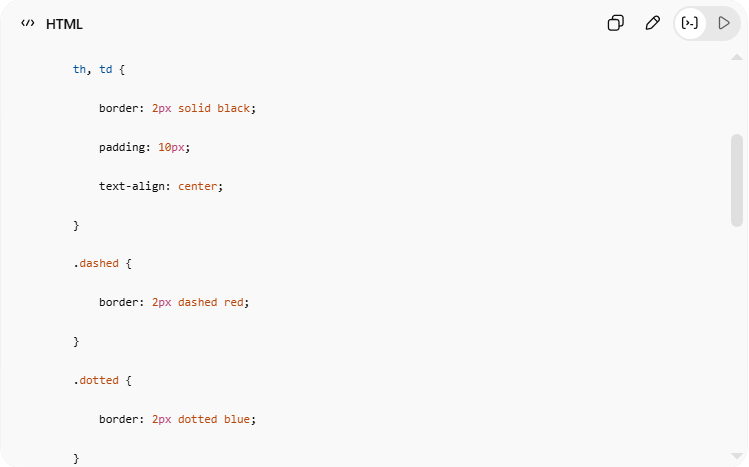
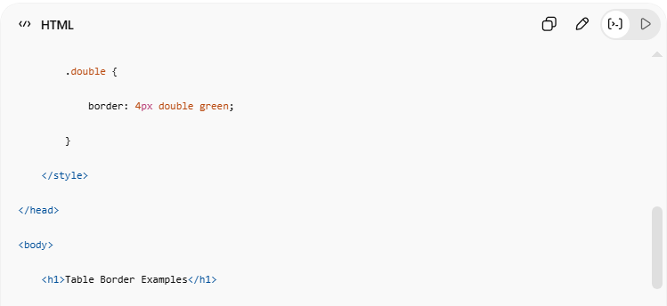
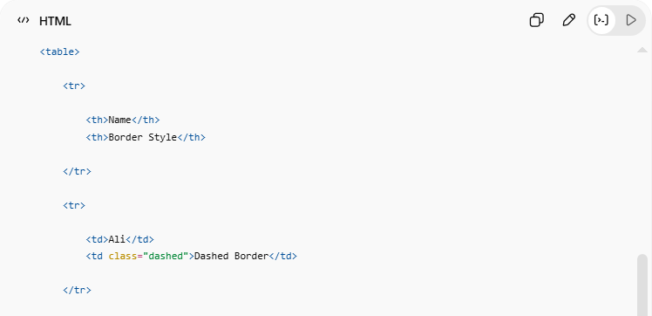
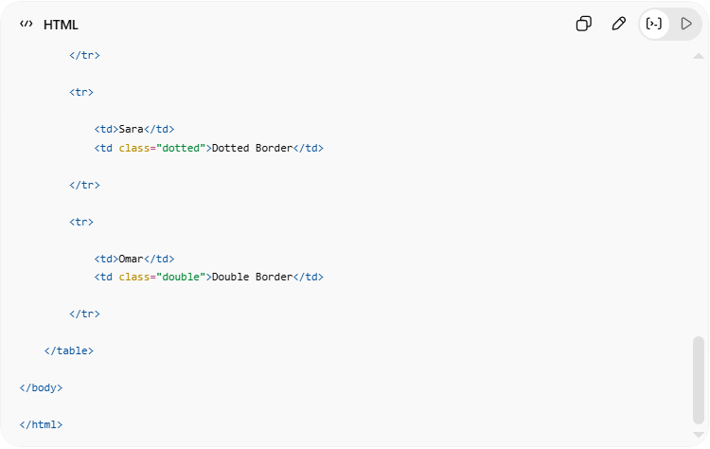
<!DOCTYPE html>
<html>
<head>
<title>HTML Table Borders</title>
<style>
table {
width: 60%;
border-collapse: collapse;
}
th, td {
border: 2px solid black;
padding: 10px;
text-align: center;
}
.dashed {
border: 2px dashed red;
}
.dotted {
border: 2px dotted blue;
}
.double {
border: 4px double green;
}
</style>
</head>
<body>
<h1>Table Border Examples</h1>
<table>
<tr>
<th>Name</th>
<th>Border Style</th>
</tr>
<tr>
<td>Ali</td>
<td class="dashed">Dashed Border</td>
</tr>
<tr>
<td>Sara</td>
<td class="dotted">Dotted Border</td>
</tr>
<tr>
<td>Omar</td>
<td class="double">Double Border</td>
</tr>
</table>
</body>
</html>

Real Example
# Source: ScreenShot Source: Provided by: [Persons Table -> ID Column: 1, Name_En Column: Motasem Essam] -> Tool: [Automation Table -> ID Column: 16, Name_En Column: Screen Capture] -> From [Operating System: Windows] on [5/6/2026]
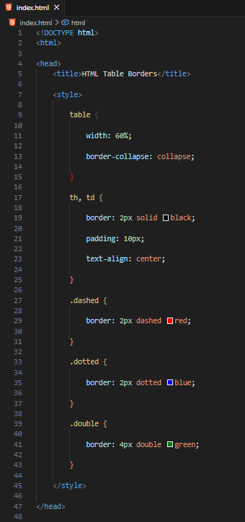

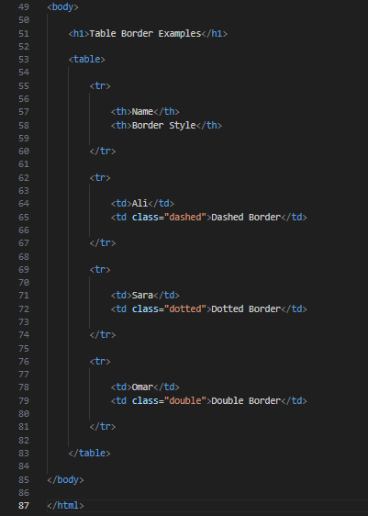
<!DOCTYPE html>
<html>

<head>
<title>HTML Table Borders</title>

<style>

table {

width: 60%;

border-collapse: collapse;

}

th, td {

border: 2px solid black;

padding: 10px;

text-align: center;

}

.dashed {

border: 2px dashed red;

}

.dotted {

border: 2px dotted blue;

}

.double {

border: 4px double green;

}

</style>

</head>

<body>

<h1>Table Border Examples</h1>

<table>

<tr>

<th>Name</th>
<th>Border Style</th>

</tr>

<tr>

<td>Ali</td>
<td class="dashed">Dashed Border</td>

</tr>

<tr>

<td>Sara</td>
<td class="dotted">Dotted Border</td>

</tr>

<tr>

<td>Omar</td>
<td class="double">Double Border</td>

</tr>

</table>

</body>

</html>
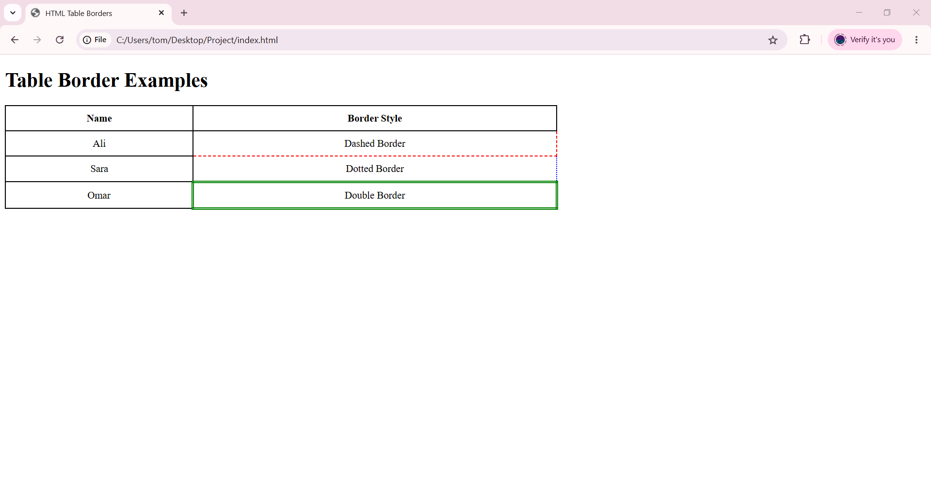

🧪 What You Can Test
# Source: AI Source: Provided by: [Data Path: Persons Table -> ID Column: 1, Name_En Column: Motasem Essam] -> From: [ChatGPT] on [5/6/2026]

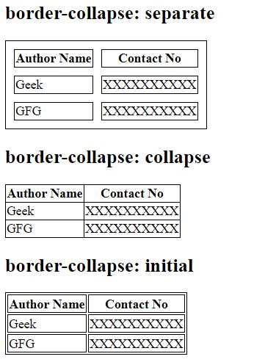
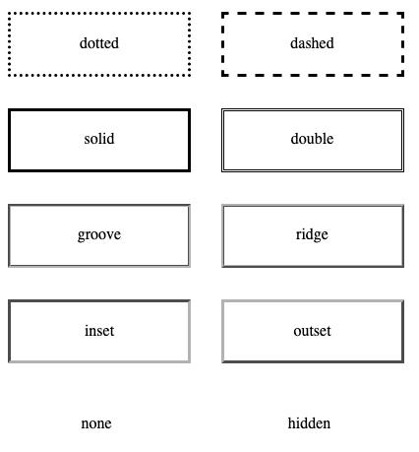
CSS Property | Result
solid | Solid line
dashed | Dashed line
dotted | Dotted line
double | Double line
border-collapse | Merges borders

⚠️ Important Notes

✅ Prefer CSS over border="1"

# Source: AI Source: Provided by: [Data Path: Persons Table -> ID Column: 1, Name_En Column: Motasem Essam] -> From: [ChatGPT] on [5/6/2026]
👉 Modern websites use CSS

✅ Use border-collapse: collapse
# Source: AI Source: Provided by: [Data Path: Persons Table -> ID Column: 1, Name_En Column: Motasem Essam] -> From: [ChatGPT] on [5/6/2026]
👉 Cleaner table appearance

❌ Avoid very thick borders
# Source: AI Source: Provided by: [Data Path: Persons Table -> ID Column: 1, Name_En Column: Motasem Essam] -> From: [ChatGPT] on [5/6/2026]
👉 Can reduce readability

📏 HTML Table Sizes
# Source: AI Source: Provided by: [Data Path: Persons Table -> ID Column: 1, Name_En Column: Motasem Essam] -> From: [ChatGPT] on [5/6/2026]
HTML table sizes are controlled using CSS width and height properties for tables, columns, and rows.
HTML table sizes control:
- table width
- column width
- row height
using CSS properties.

📋 Common Table Size Properties
# Source: AI Source: Provided by: [Data Path: Persons Table -> ID Column: 1, Name_En Column: Motasem Essam] -> From: [ChatGPT] on [5/6/2026]
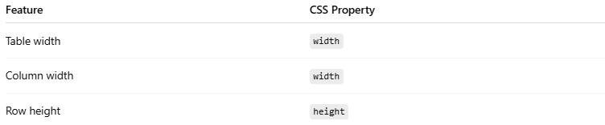
Feature | CSS Property
Table width | width
Column width | width
Row height | height

1. 📐 HTML Table Width
# Source: AI Source: Provided by: [Data Path: Persons Table -> ID Column: 1, Name_En Column: Motasem Essam] -> From: [ChatGPT] on [5/6/2026]
📖 Description
Controls the width of the entire table
💻 Example:
<table style="width: 80%;">
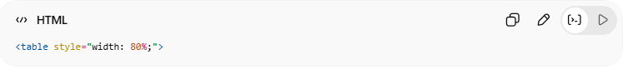
👉 Table uses 80% of page width
💻 Another Example:
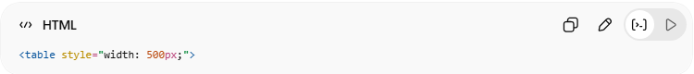
<table style="width: 500px;">
👉 Fixed table width

2. 📏 HTML Table Column Width
# Source: AI Source: Provided by: [Data Path: Persons Table -> ID Column: 1, Name_En Column: Motasem Essam] -> From: [ChatGPT] on [5/6/2026]
📖 Description
Controls the width of a specific column.
💻 Example:
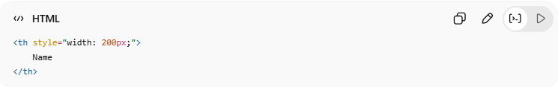
<th style="width: 200px;">
Name
</th>
👉 Sets column width

3. 📦 HTML Table Row Height
# Source: AI Source: Provided by: [Data Path: Persons Table -> ID Column: 1, Name_En Column: Motasem Essam] -> From: [ChatGPT] on [5/6/2026]
📖 Description
Controls row height.
💻 Example:
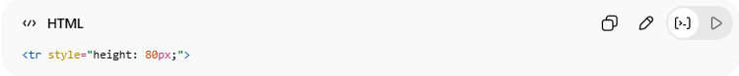
<tr style="height: 80px;">
👉 Makes row taller

💻 Example

Full Example
# Source: AI Source: Provided by: [Data Path: Persons Table -> ID Column: 1, Name_En Column: Motasem Essam] -> From: [ChatGPT] on [5/6/2026]
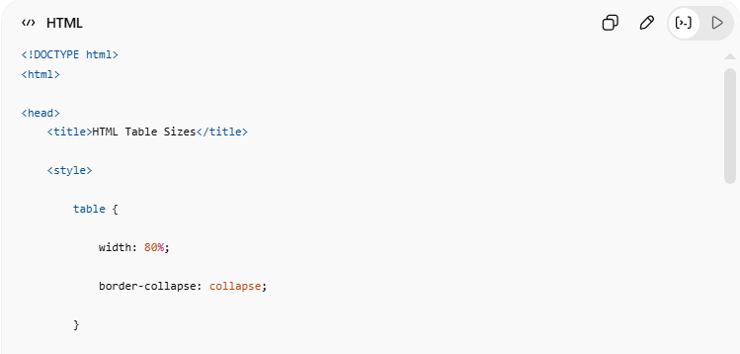
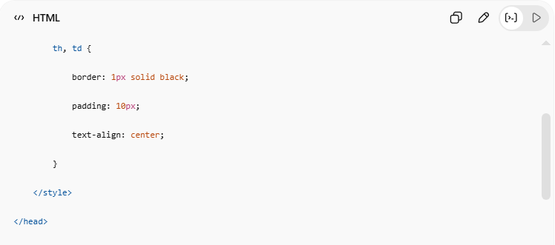
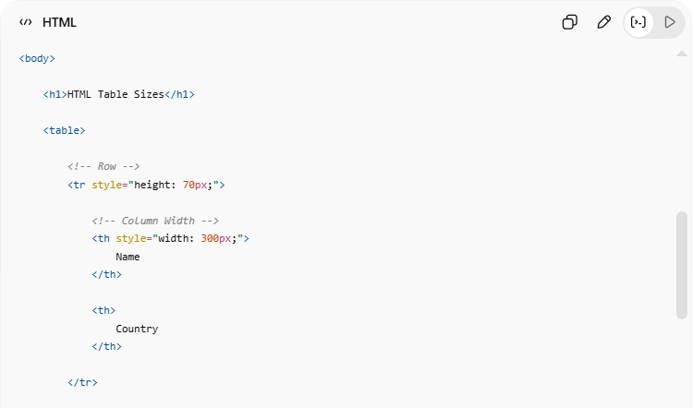
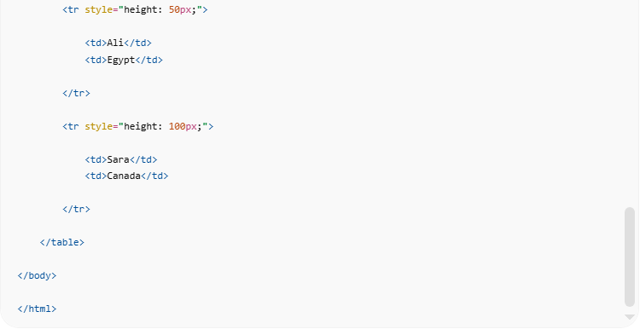
<!DOCTYPE html>
<html>
<head>
<title>HTML Table Sizes</title>
<style>
table {
width: 80%;
border-collapse: collapse;
}
th, td {
border: 1px solid black;
padding: 10px;
text-align: center;
}
</style>
</head>
<body>
<h1>HTML Table Sizes</h1>
<table>
<!-- Row -->
<tr style="height: 70px;">
<!-- Column Width -->
<th style="width: 300px;">
Name
</th>
<th>
Country
</th>
</tr>
<tr style="height: 50px;">
<td>Ali</td>
<td>Egypt</td>
</tr>
<tr style="height: 100px;">
<td>Sara</td>
<td>Canada</td>
</tr>
</table>
</body>
</html>

Real Example
# Source: ScreenShot Source: Provided by: [Persons Table -> ID Column: 1, Name_En Column: Motasem Essam] -> Tool: [Automation Table -> ID Column: 16, Name_En Column: Screen Capture] -> From [Operating System: Windows] on [5/6/2026]
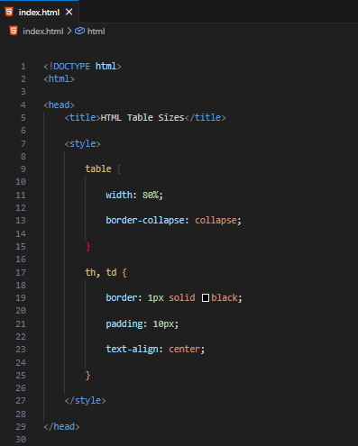
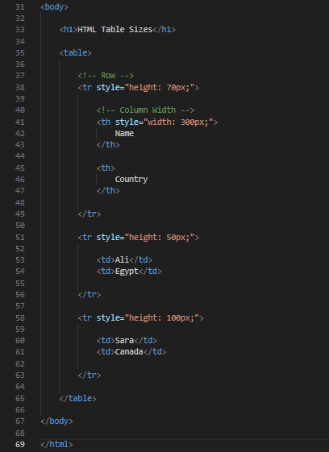
<!DOCTYPE html>
<html>

<head>
<title>HTML Table Sizes</title>

<style>

table {

width: 80%;

border-collapse: collapse;

}

th, td {

border: 1px solid black;

padding: 10px;

text-align: center;

}

</style>

</head>

<body>

<h1>HTML Table Sizes</h1>

<table>

<!-- Row -->
<tr style="height: 70px;">

<!-- Column Width -->
<th style="width: 300px;">
Name
</th>

<th>
Country
</th>

</tr>

<tr style="height: 50px;">

<td>Ali</td>
<td>Egypt</td>

</tr>

<tr style="height: 100px;">

<td>Sara</td>
<td>Canada</td>

</tr>

</table>

</body>

</html>
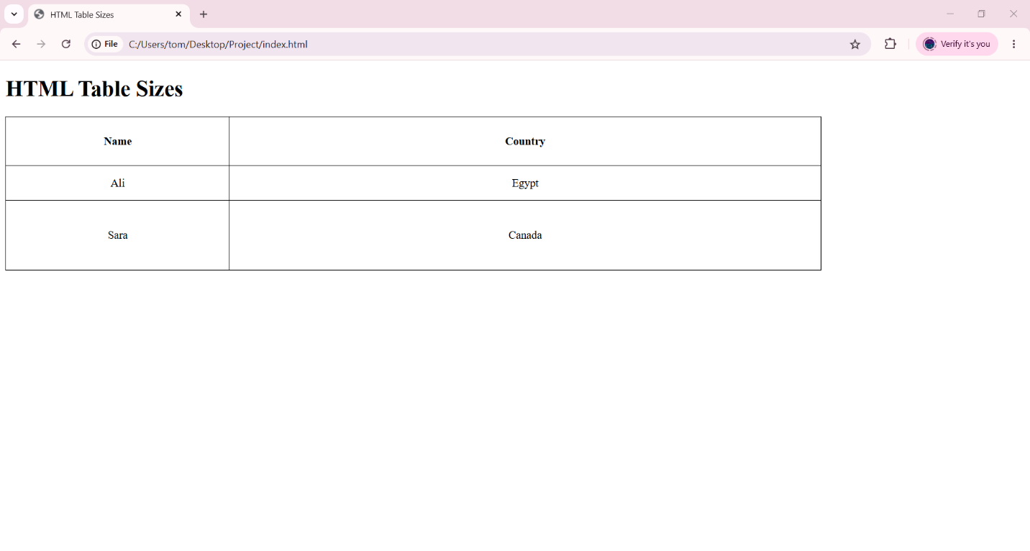

🧪 What You Can Test
# Source: AI Source: Provided by: [Data Path: Persons Table -> ID Column: 1, Name_En Column: Motasem Essam] -> From: [ChatGPT] on [5/6/2026]
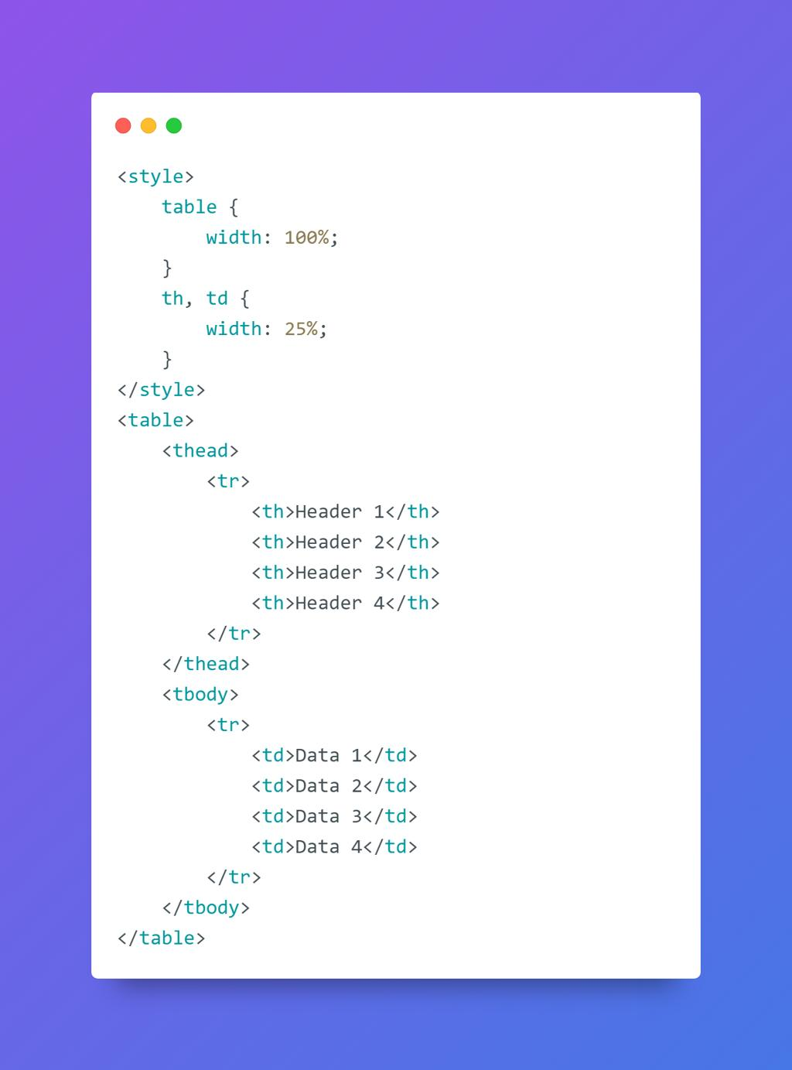
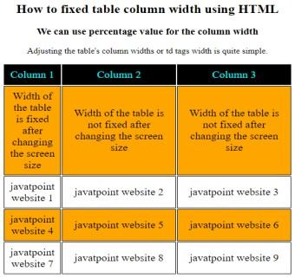
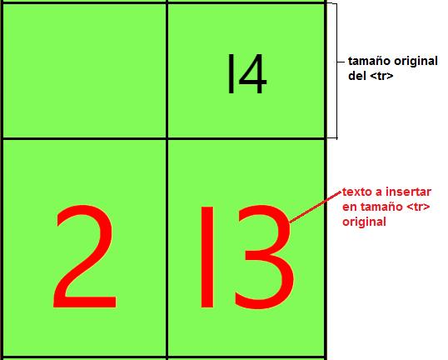
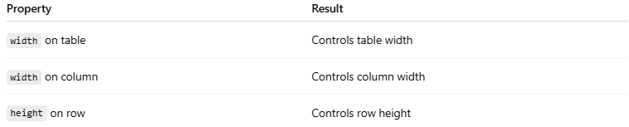
Property | Result
width on table | Controls table width
width on column | Controls column width
height on row | Controls row height

⚠️ Important Notes

✅ Use percentages for responsive tables
# Source: AI Source: Provided by: [Data Path: Persons Table -> ID Column: 1, Name_En Column: Motasem Essam] -> From: [ChatGPT] on [5/6/2026]
💻 Example:
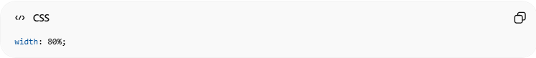
width: 80%;
👉 Better for different screen sizes

✅ Use pixels for fixed layouts
# Source: AI Source: Provided by: [Data Path: Persons Table -> ID Column: 1, Name_En Column: Motasem Essam] -> From: [ChatGPT] on [5/6/2026]
💻 Example:
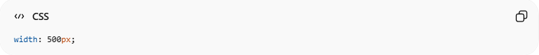
width: 500px;

❌ Avoid extremely large row heights
# Source: AI Source: Provided by: [Data Path: Persons Table -> ID Column: 1, Name_En Column: Motasem Essam] -> From: [ChatGPT] on [5/6/2026]
👉 Can waste space and reduce readability

📊 HTML Table Headers
# Source: AI Source: Provided by: [Data Path: Persons Table -> ID Column: 1, Name_En Column: Motasem Essam] -> From: [ChatGPT] on [5/6/2026]
HTML table headers use <th> to label rows and columns, support alignment, vertical headers, grouped headers, and captions for better organization.
Table headers define titles for table rows or columns using the <th> element.
Headers improve:
- readability
- organization
- accessibility

🧠 Main Header Elements
# Source: AI Source: Provided by: [Data Path: Persons Table -> ID Column: 1, Name_En Column: Motasem Essam] -> From: [ChatGPT] on [5/6/2026]
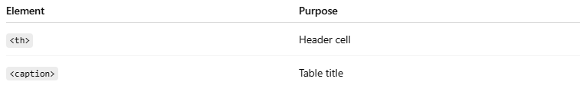
Element | Purpose
<th> | Header cell
<caption> | Table title

1. 🔠 HTML Table Headers
# Source: AI Source: Provided by: [Data Path: Persons Table -> ID Column: 1, Name_En Column: Motasem Essam] -> From: [ChatGPT] on [5/6/2026]
📖 Description
<th> creates header cells.
👉 Browsers display them:
- bold
- centered
by default.
💻 Example:
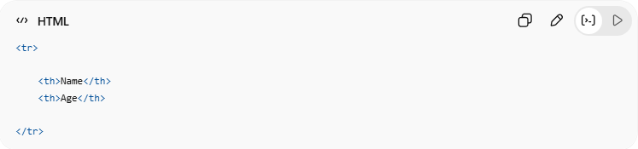
<tr>
<th>Name</th>
<th>Age</th>
</tr>

2. ↕️ Vertical Table Headers
# Source: AI Source: Provided by: [Data Path: Persons Table -> ID Column: 1, Name_En Column: Motasem Essam] -> From: [ChatGPT] on [5/6/2026]
📖 Description
Headers can appear vertically on the left side of rows.
💻 Example:
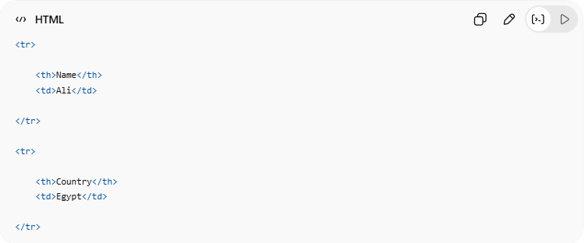
<tr>
<th>Name</th>
<td>Ali</td>
</tr>
<tr>
<th>Country</th>
<td>Egypt</td>
</tr>
👉 Left-side headers describe each row

3. 📍 Align Table Headers
# Source: AI Source: Provided by: [Data Path: Persons Table -> ID Column: 1, Name_En Column: Motasem Essam] -> From: [ChatGPT] on [5/6/2026]
📖 Description
Header text alignment can be controlled using CSS.
💻 Example:
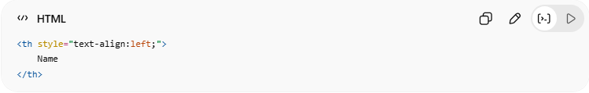
<th style="text-align:left;">
Name
</th>
🔤 Common Alignment Values
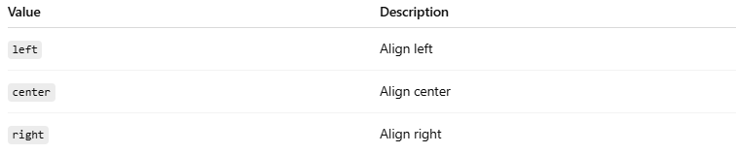
Value | Description
left | Align left
center | Align center
right | Align right

4. 🧩 Header for Multiple Columns
# Source: AI Source: Provided by: [Data Path: Persons Table -> ID Column: 1, Name_En Column: Motasem Essam] -> From: [ChatGPT] on [5/6/2026]
📖 Description
The colspan attribute allows one header to span multiple columns.
💻 Example:
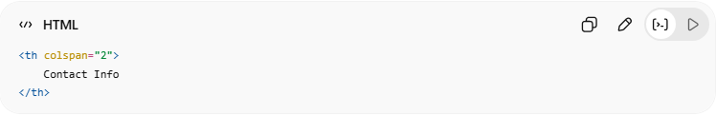
<th colspan="2">
Contact Info
</th>
👉 Header covers multiple columns

5. 🏷️ Table Caption
# Source: AI Source: Provided by: [Data Path: Persons Table -> ID Column: 1, Name_En Column: Motasem Essam] -> From: [ChatGPT] on [5/6/2026]
📖 Description
<caption> adds a title to the table.
💻 Example:
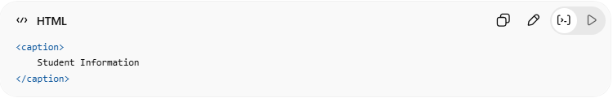
<caption>
Student Information
</caption>
👉 Displays table title

💻 Example

Full Example
# Source: AI Source: Provided by: [Data Path: Persons Table -> ID Column: 1, Name_En Column: Motasem Essam] -> From: [ChatGPT] on [5/6/2026]
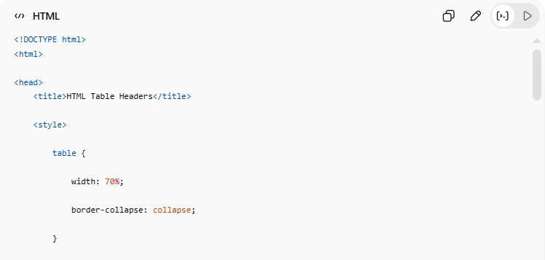
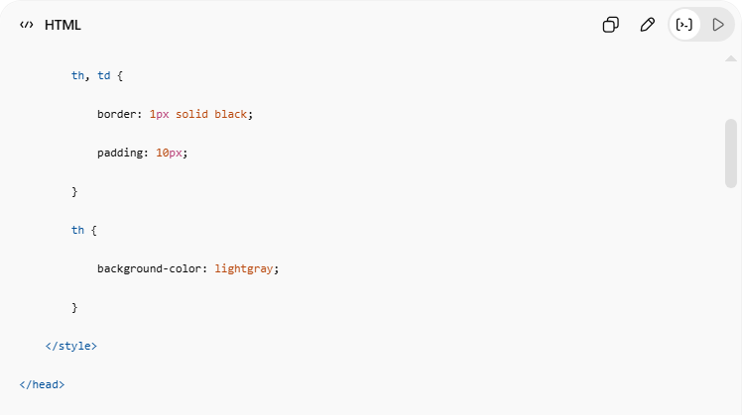
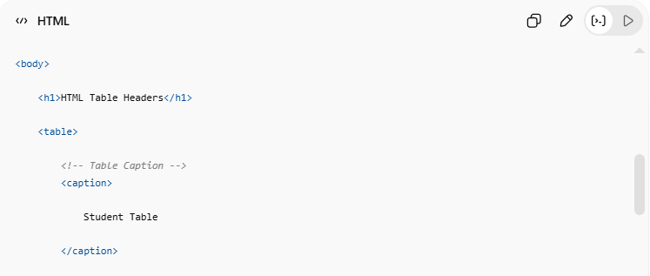
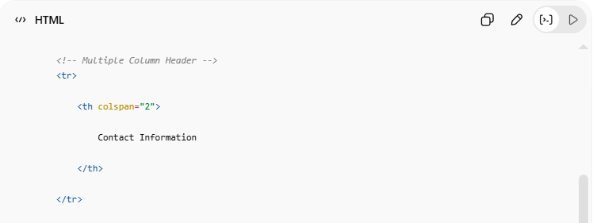
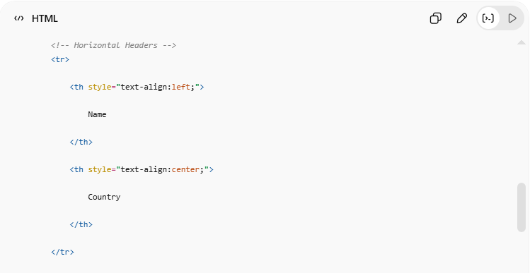
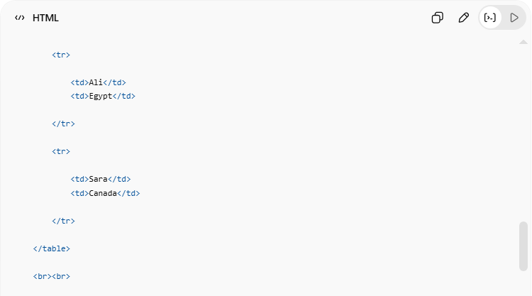
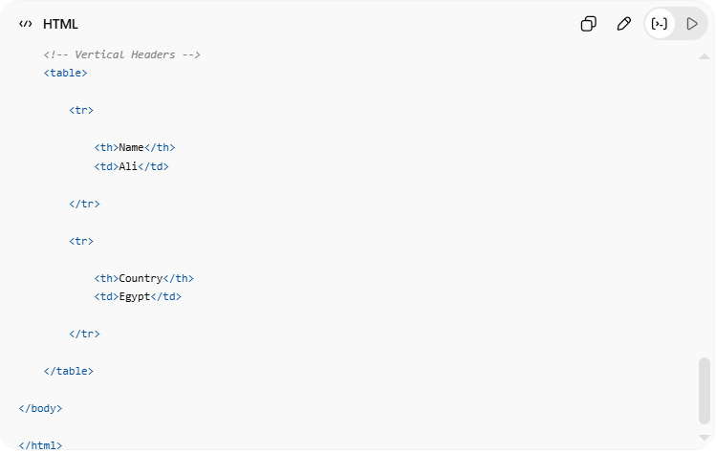
<!DOCTYPE html>
<html>
<head>
<title>HTML Table Headers</title>
<style>
table {
width: 70%;
border-collapse: collapse;
}
th, td {
border: 1px solid black;
padding: 10px;
}
th {
background-color: lightgray;
}
</style>
</head>
<body>
<h1>HTML Table Headers</h1>
<table>
<!-- Table Caption -->
<caption>
Student Table
</caption>
<!-- Multiple Column Header -->
<tr>
<th colspan="2">
Contact Information
</th>
</tr>
<!-- Horizontal Headers -->
<tr>
<th style="text-align:left;">
Name
</th>
<th style="text-align:center;">
Country
</th>
</tr>
<tr>
<td>Ali</td>
<td>Egypt</td>
</tr>
<tr>
<td>Sara</td>
<td>Canada</td>
</tr>
</table>
<br><br>
<!-- Vertical Headers -->
<table>
<tr>
<th>Name</th>
<td>Ali</td>
</tr>
<tr>
<th>Country</th>
<td>Egypt</td>
</tr>
</table>
</body>
</html>

Real Example
# Source: ScreenShot Source: Provided by: [Persons Table -> ID Column: 1, Name_En Column: Motasem Essam] -> Tool: [Automation Table -> ID Column: 16, Name_En Column: Screen Capture] -> From [Operating System: Windows] on [5/6/2026]
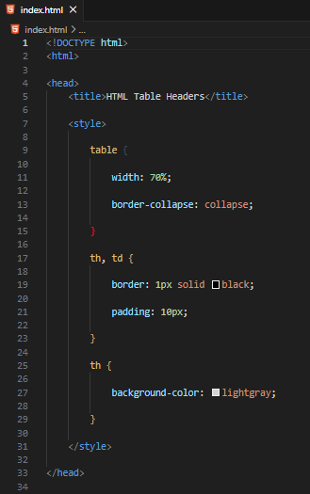
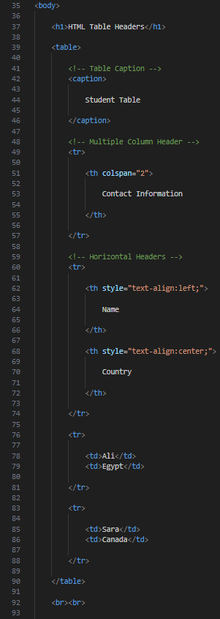
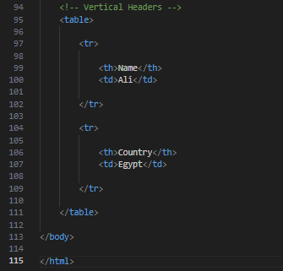
<!DOCTYPE html>
<html>

<head>
<title>HTML Table Headers</title>

<style>

table {

width: 70%;

border-collapse: collapse;

}

th, td {

border: 1px solid black;

padding: 10px;

}

th {

background-color: lightgray;

}

</style>

</head>

<body>

<h1>HTML Table Headers</h1>

<table>

<!-- Table Caption -->
<caption>

Student Table

</caption>

<!-- Multiple Column Header -->
<tr>

<th colspan="2">

Contact Information

</th>

</tr>

<!-- Horizontal Headers -->
<tr>

<th style="text-align:left;">

Name

</th>

<th style="text-align:center;">

Country

</th>

</tr>

<tr>

<td>Ali</td>
<td>Egypt</td>

</tr>

<tr>

<td>Sara</td>
<td>Canada</td>

</tr>

</table>

<br><br>

<!-- Vertical Headers -->
<table>

<tr>

<th>Name</th>
<td>Ali</td>

</tr>

<tr>

<th>Country</th>
<td>Egypt</td>

</tr>

</table>

</body>

</html>
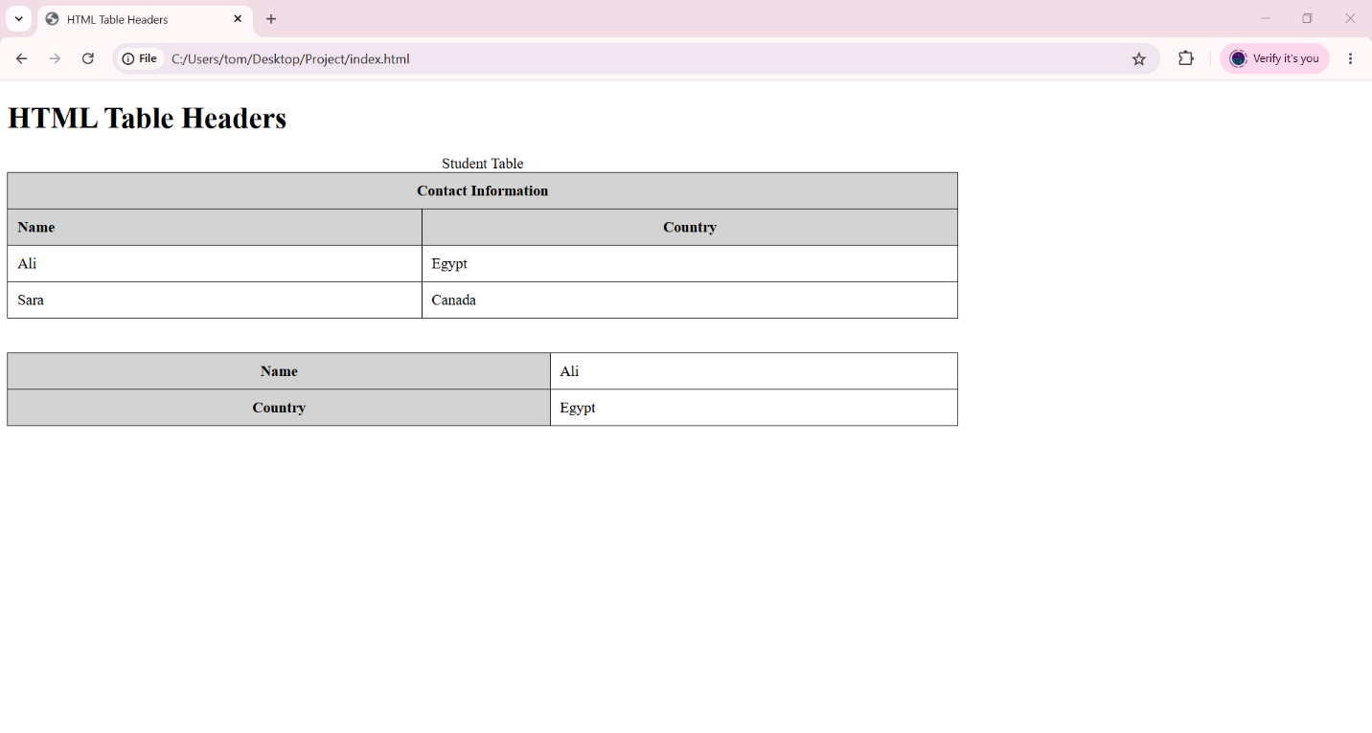

🧪 What You Can Test
# Source: AI Source: Provided by: [Data Path: Persons Table -> ID Column: 1, Name_En Column: Motasem Essam] -> From: [ChatGPT] on [5/6/2026]
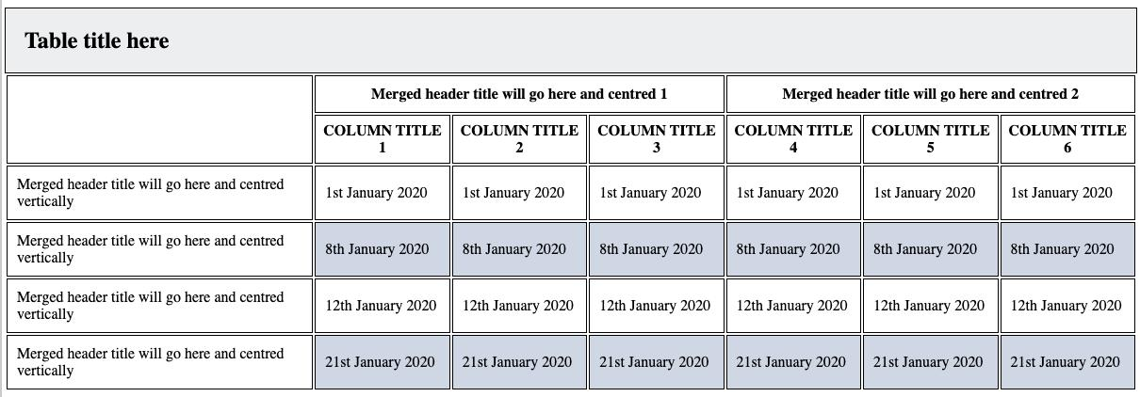
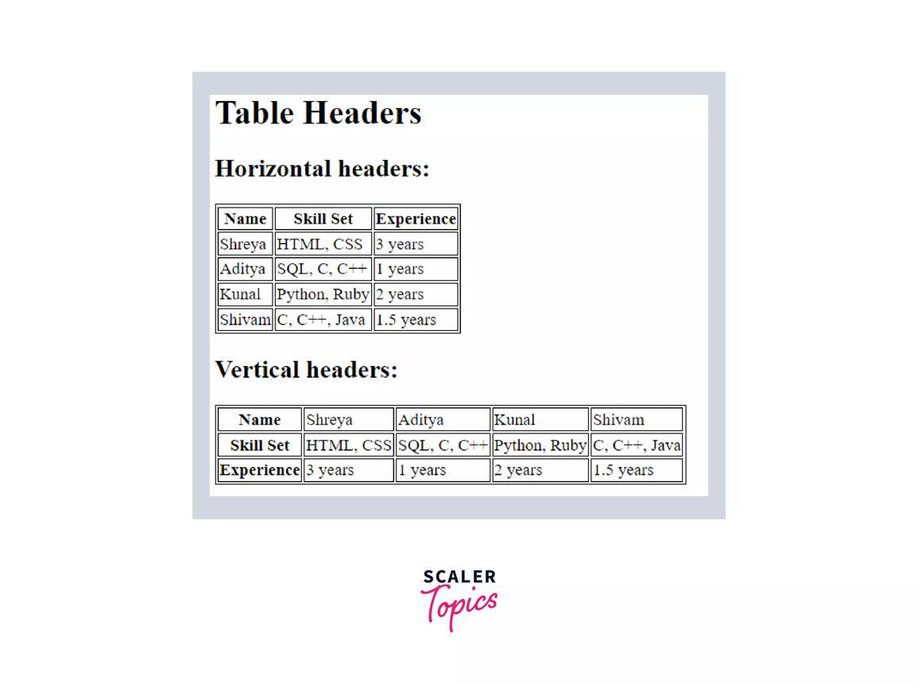
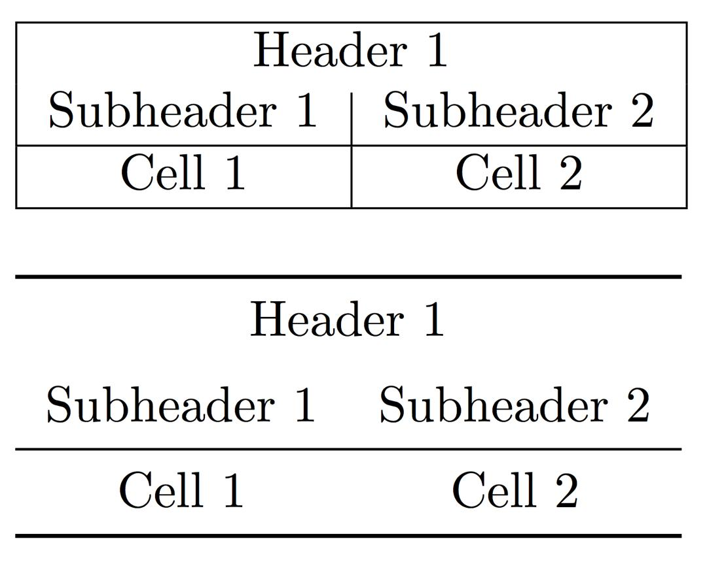
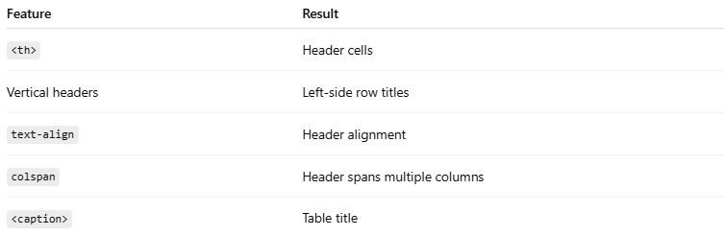
Feature | Result
<th> | Header cells
Vertical headers | Left-side row titles
text-align | Header alignment
colspan | Header spans multiple columns
<caption> | Table title

⚠️ Important Notes

✅ Use <th> instead of <td> for headers
# Source: AI Source: Provided by: [Data Path: Persons Table -> ID Column: 1, Name_En Column: Motasem Essam] -> From: [ChatGPT] on [5/6/2026]
👉 Improves accessibility and semantics

✅ Use <caption> for table titles
# Source: AI Source: Provided by: [Data Path: Persons Table -> ID Column: 1, Name_En Column: Motasem Essam] -> From: [ChatGPT] on [5/6/2026]
👉 Better organization and accessibility

✅ Use colspan carefully
# Source: AI Source: Provided by: [Data Path: Persons Table -> ID Column: 1, Name_En Column: Motasem Essam] -> From: [ChatGPT] on [5/6/2026]
👉 Incorrect values may break table layout

📏 HTML Table Padding & Spacing
# Source: AI Source: Provided by: [Data Path: Persons Table -> ID Column: 1, Name_En Column: Motasem Essam] -> From: [ChatGPT] on [5/6/2026]
Cell padding adds space inside table cells, while cell spacing adds space between table cells.
Padding and spacing control the space:
- inside table cells
- between table cells
using CSS.

🧠 Main Concepts
# Source: AI Source: Provided by: [Data Path: Persons Table -> ID Column: 1, Name_En Column: Motasem Essam] -> From: [ChatGPT] on [5/6/2026]
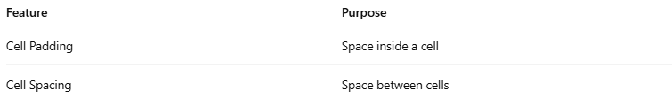
Feature | Purpose
Cell Padding | Space inside a cell
Cell Spacing | Space between cells

1. 📦 HTML Table — Cell Padding
# Source: AI Source: Provided by: [Data Path: Persons Table -> ID Column: 1, Name_En Column: Motasem Essam] -> From: [ChatGPT] on [5/6/2026]
📖 Description
Cell padding adds space between:
- cell content
- cell border
using the CSS padding property.
💻 Example:
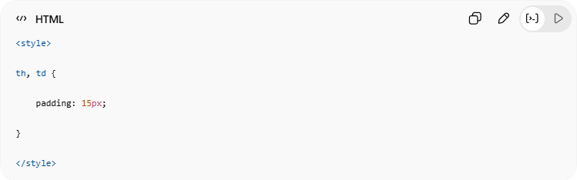
<style>
th, td {
padding: 15px;
}
</style>
👉 Makes table cells more spacious
🔤 Common Padding Values
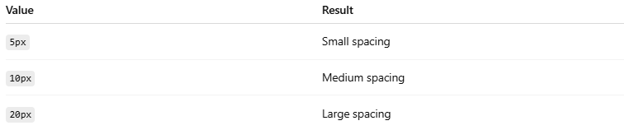
Value | Result
5px | Small spacing
10px | Medium spacing
20px | Large spacing

2. ↔️ HTML Table — Cell Spacing
# Source: AI Source: Provided by: [Data Path: Persons Table -> ID Column: 1, Name_En Column: Motasem Essam] -> From: [ChatGPT] on [5/6/2026]
📖 Description
Cell spacing adds space between table cells.
Modern websites use:

border-spacing
💻 Example:
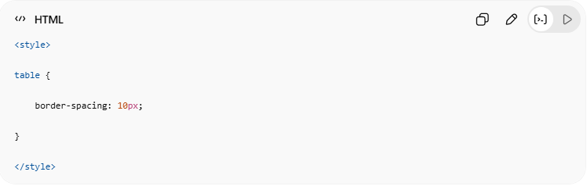
<style>
table {
border-spacing: 10px;
}
</style>
👉 Adds gaps between cells

⚠️ Important Note
border-spacing only works when:
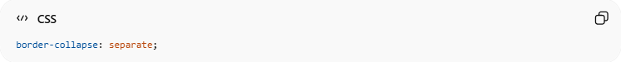
border-collapse: separate;

💻 Example

Full Example
# Source: AI Source: Provided by: [Data Path: Persons Table -> ID Column: 1, Name_En Column: Motasem Essam] -> From: [ChatGPT] on [5/6/2026]
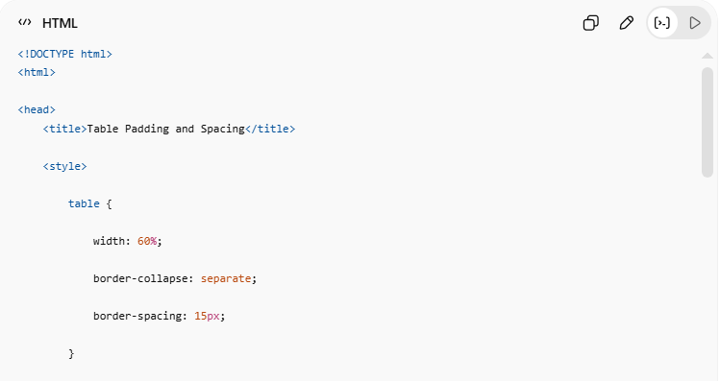
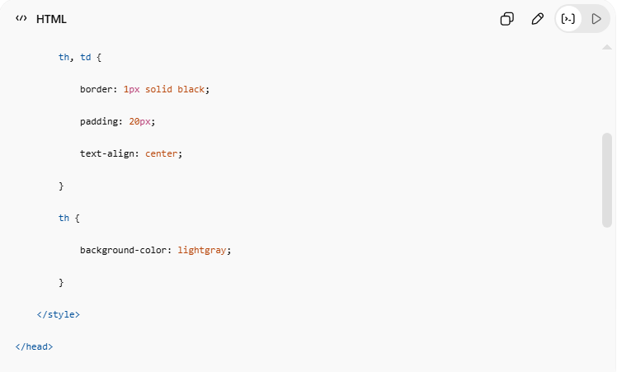
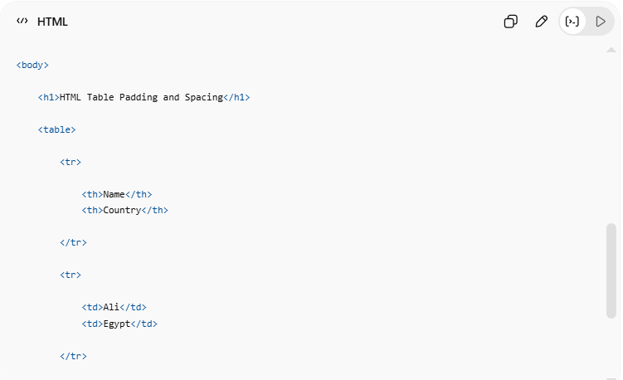
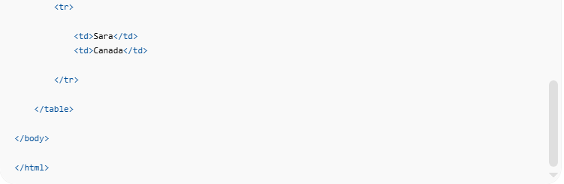
<!DOCTYPE html>
<html>
<head>
<title>Table Padding and Spacing</title>
<style>
table {
width: 60%;
border-collapse: separate;
border-spacing: 15px;
}
th, td {
border: 1px solid black;
padding: 20px;
text-align: center;
}
th {
background-color: lightgray;
}
</style>
</head>
<body>
<h1>HTML Table Padding and Spacing</h1>
<table>
<tr>
<th>Name</th>
<th>Country</th>
</tr>
<tr>
<td>Ali</td>
<td>Egypt</td>
</tr>
<tr>
<td>Sara</td>
<td>Canada</td>
</tr>
</table>
</body>
</html>

Real Example
# Source: ScreenShot Source: Provided by: [Persons Table -> ID Column: 1, Name_En Column: Motasem Essam] -> Tool: [Automation Table -> ID Column: 16, Name_En Column: Screen Capture] -> From [Operating System: Windows] on [5/6/2026]
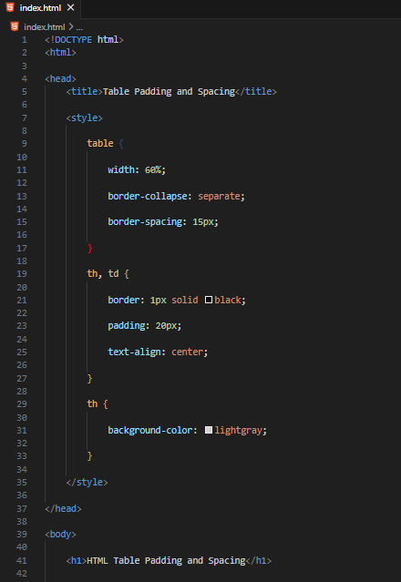
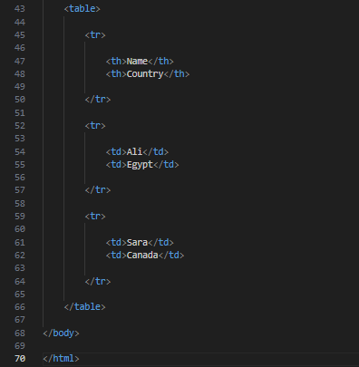
<!DOCTYPE html>
<html>

<head>
<title>Table Padding and Spacing</title>

<style>

table {

width: 60%;

border-collapse: separate;

border-spacing: 15px;

}

th, td {

border: 1px solid black;

padding: 20px;

text-align: center;

}

th {

background-color: lightgray;

}

</style>

</head>

<body>

<h1>HTML Table Padding and Spacing</h1>

<table>

<tr>

<th>Name</th>
<th>Country</th>

</tr>

<tr>

<td>Ali</td>
<td>Egypt</td>

</tr>

<tr>

<td>Sara</td>
<td>Canada</td>

</tr>

</table>

</body>

</html>
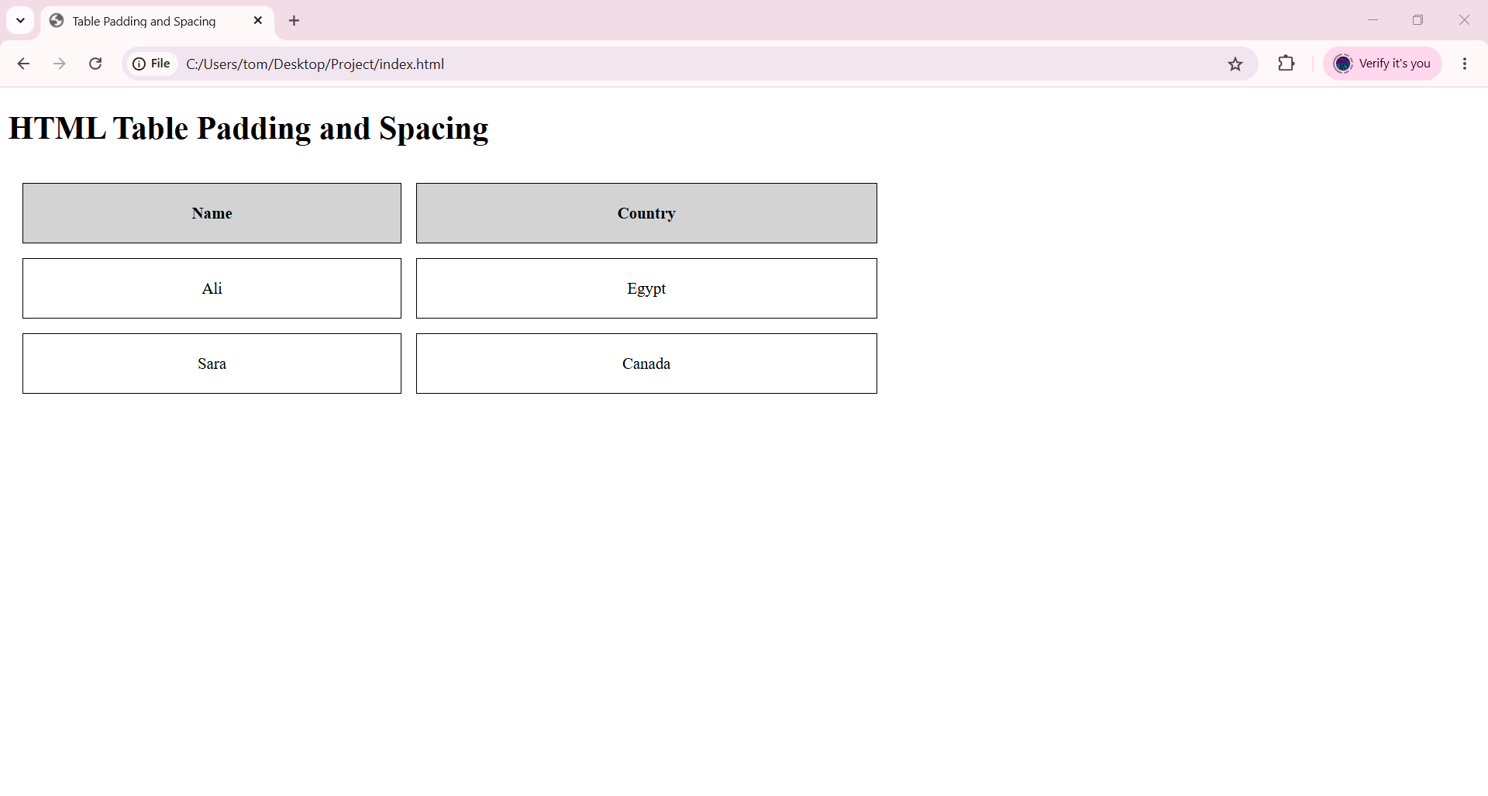

🧪 What You Can Test
# Source: AI Source: Provided by: [Data Path: Persons Table -> ID Column: 1, Name_En Column: Motasem Essam] -> From: [ChatGPT] on [5/6/2026]
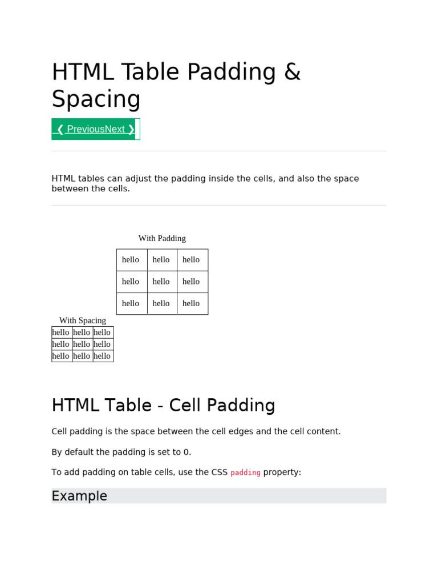
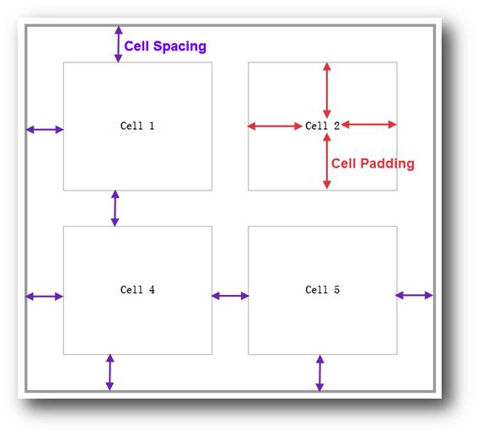
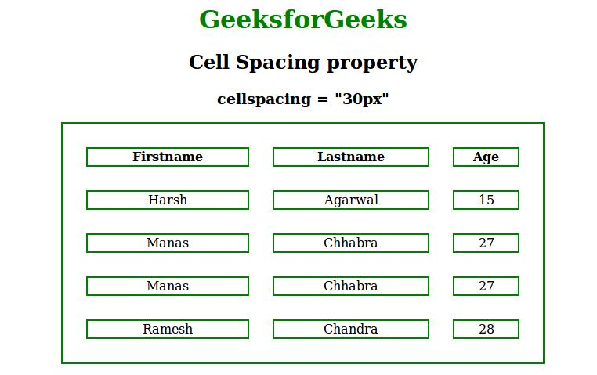
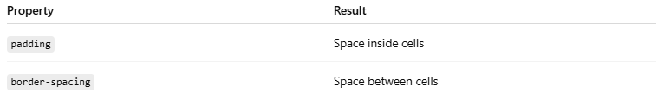
Property | Result
padding | Space inside cells
border-spacing | Space between cells

⚠️ Important Notes

✅ padding affects cell content spacing
# Source: AI Source: Provided by: [Data Path: Persons Table -> ID Column: 1, Name_En Column: Motasem Essam] -> From: [ChatGPT] on [5/6/2026]
💻 Example:
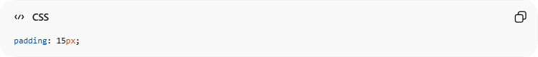
padding: 15px;

✅ border-spacing affects gaps between cells
# Source: AI Source: Provided by: [Data Path: Persons Table -> ID Column: 1, Name_En Column: Motasem Essam] -> From: [ChatGPT] on [5/6/2026]
💻 Example:
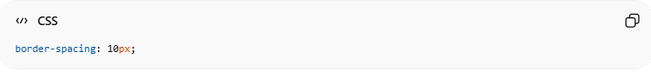
border-spacing: 10px;

❌ border-spacing does NOT work with:
# Source: AI Source: Provided by: [Data Path: Persons Table -> ID Column: 1, Name_En Column: Motasem Essam] -> From: [ChatGPT] on [5/6/2026]
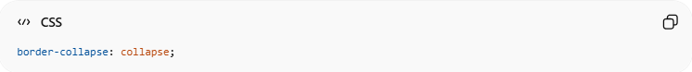
border-collapse: collapse;

📊 HTML Table Colspan & Rowspan
# Source: AI Source: Provided by: [Data Path: Persons Table -> ID Column: 1, Name_En Column: Motasem Essam] -> From: [ChatGPT] on [5/6/2026]
colspan merges table columns, while rowspan merges table rows.
colspan and rowspan are HTML table attributes used to merge table cells.
They allow cells to span:
- multiple columns
- multiple rows

🧠 Main Attributes
# Source: AI Source: Provided by: [Data Path: Persons Table -> ID Column: 1, Name_En Column: Motasem Essam] -> From: [ChatGPT] on [5/6/2026]
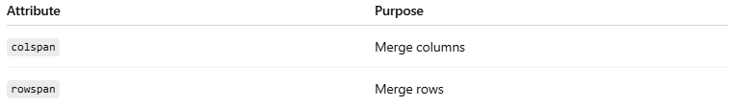
Attribute | Purpose
colspan | Merge columns
rowspan | Merge rows

1. ↔️ HTML Table — colspan
# Source: AI Source: Provided by: [Data Path: Persons Table -> ID Column: 1, Name_En Column: Motasem Essam] -> From: [ChatGPT] on [5/6/2026]
📖 Description
colspan allows one cell to span across multiple columns.
💻 Example:
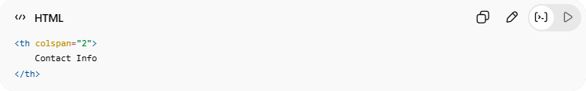
<th colspan="2">
Contact Info
</th>
👉 The header spans 2 columns

🌐 Result Example
Contact Info
Name

2. ↕️ HTML Table — rowspan
# Source: AI Source: Provided by: [Data Path: Persons Table -> ID Column: 1, Name_En Column: Motasem Essam] -> From: [ChatGPT] on [5/6/2026]
📖 Description
rowspan allows one cell to span across multiple rows.
💻 Example:
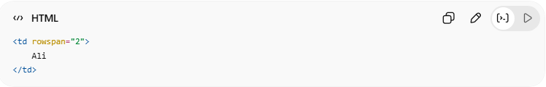
<td rowspan="2">
Ali
</td>
👉 The cell spans 2 rows
🌐 Result Example
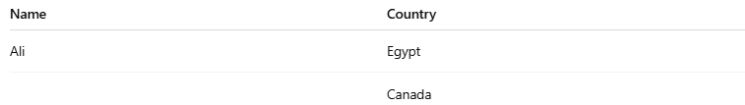
Name | Country
Ali | Egypt
 | Canada

💻 Example

Full Example
# Source: AI Source: Provided by: [Data Path: Persons Table -> ID Column: 1, Name_En Column: Motasem Essam] -> From: [ChatGPT] on [5/6/2026]
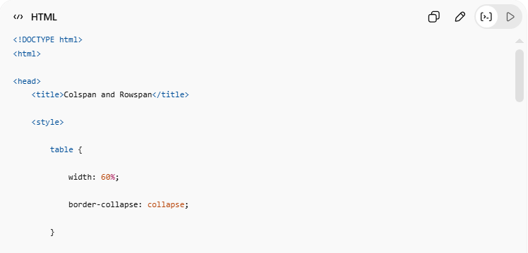
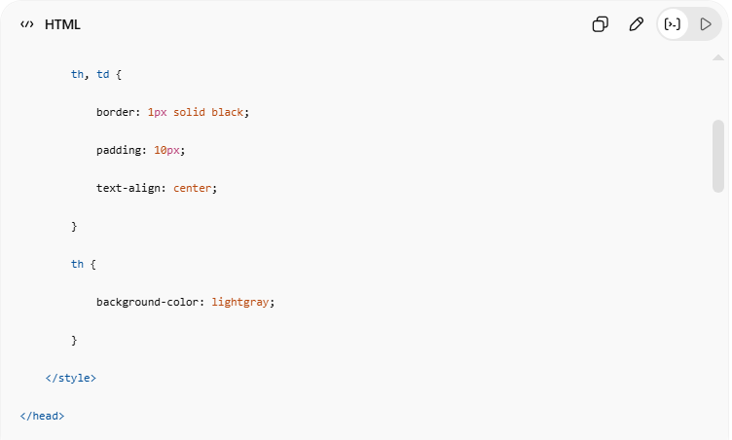
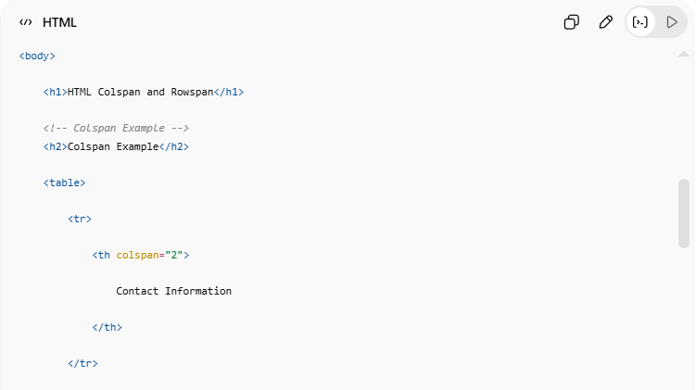
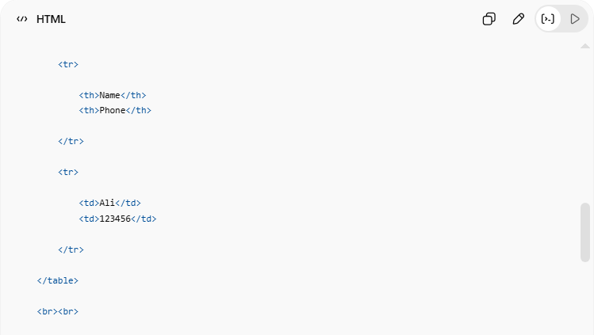
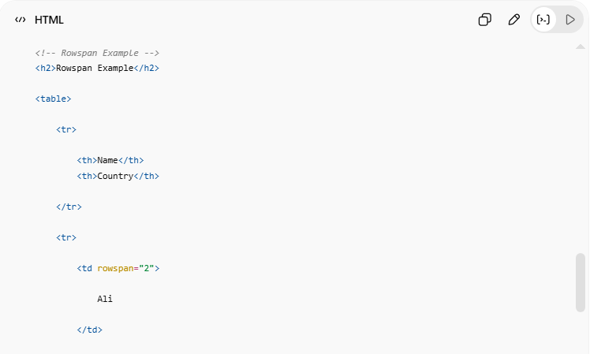
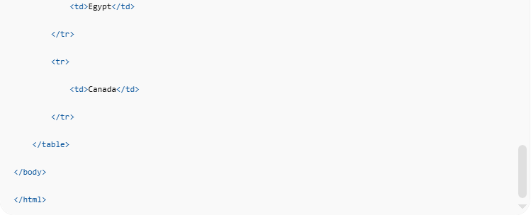
<!DOCTYPE html>
<html>
<head>
<title>Colspan and Rowspan</title>
<style>
table {
width: 60%;
border-collapse: collapse;
}
th, td {
border: 1px solid black;
padding: 10px;
text-align: center;
}
th {
background-color: lightgray;
}
</style>
</head>
<body>
<h1>HTML Colspan and Rowspan</h1>
<!-- Colspan Example -->
<h2>Colspan Example</h2>
<table>
<tr>
<th colspan="2">
Contact Information
</th>
</tr>
<tr>
<th>Name</th>
<th>Phone</th>
</tr>
<tr>
<td>Ali</td>
<td>123456</td>
</tr>
</table>
<br><br>
<!-- Rowspan Example -->
<h2>Rowspan Example</h2>
<table>
<tr>
<th>Name</th>
<th>Country</th>
</tr>
<tr>
<td rowspan="2">
Ali
</td>
<td>Egypt</td>
</tr>
<tr>
<td>Canada</td>
</tr>
</table>
</body>
</html>

Real Example
# Source: ScreenShot Source: Provided by: [Persons Table -> ID Column: 1, Name_En Column: Motasem Essam] -> Tool: [Automation Table -> ID Column: 16, Name_En Column: Screen Capture] -> From [Operating System: Windows] on [5/6/2026]
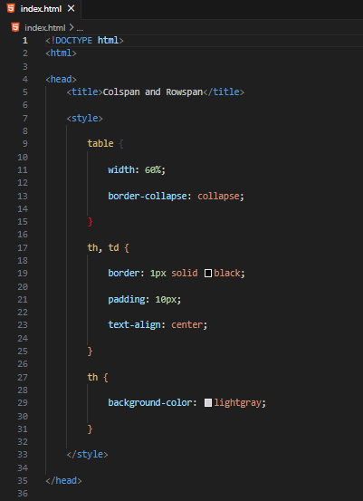
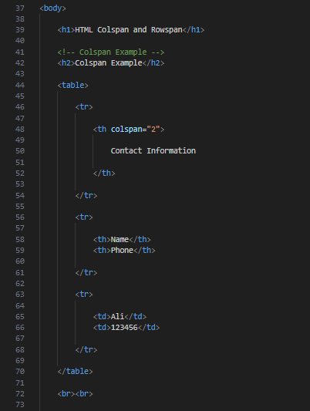
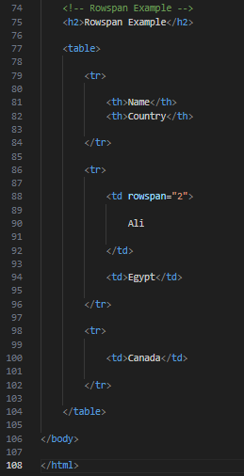
<!DOCTYPE html>
<html>

<head>
<title>Colspan and Rowspan</title>

<style>

table {

width: 60%;

border-collapse: collapse;

}

th, td {

border: 1px solid black;

padding: 10px;

text-align: center;

}

th {

background-color: lightgray;

}

</style>

</head>

<body>

<h1>HTML Colspan and Rowspan</h1>

<!-- Colspan Example -->
<h2>Colspan Example</h2>

<table>

<tr>

<th colspan="2">

Contact Information

</th>

</tr>

<tr>

<th>Name</th>
<th>Phone</th>

</tr>

<tr>

<td>Ali</td>
<td>123456</td>

</tr>

</table>

<br><br>

<!-- Rowspan Example -->
<h2>Rowspan Example</h2>

<table>

<tr>

<th>Name</th>
<th>Country</th>

</tr>

<tr>

<td rowspan="2">

Ali

</td>

<td>Egypt</td>

</tr>

<tr>

<td>Canada</td>

</tr>

</table>

</body>

</html>
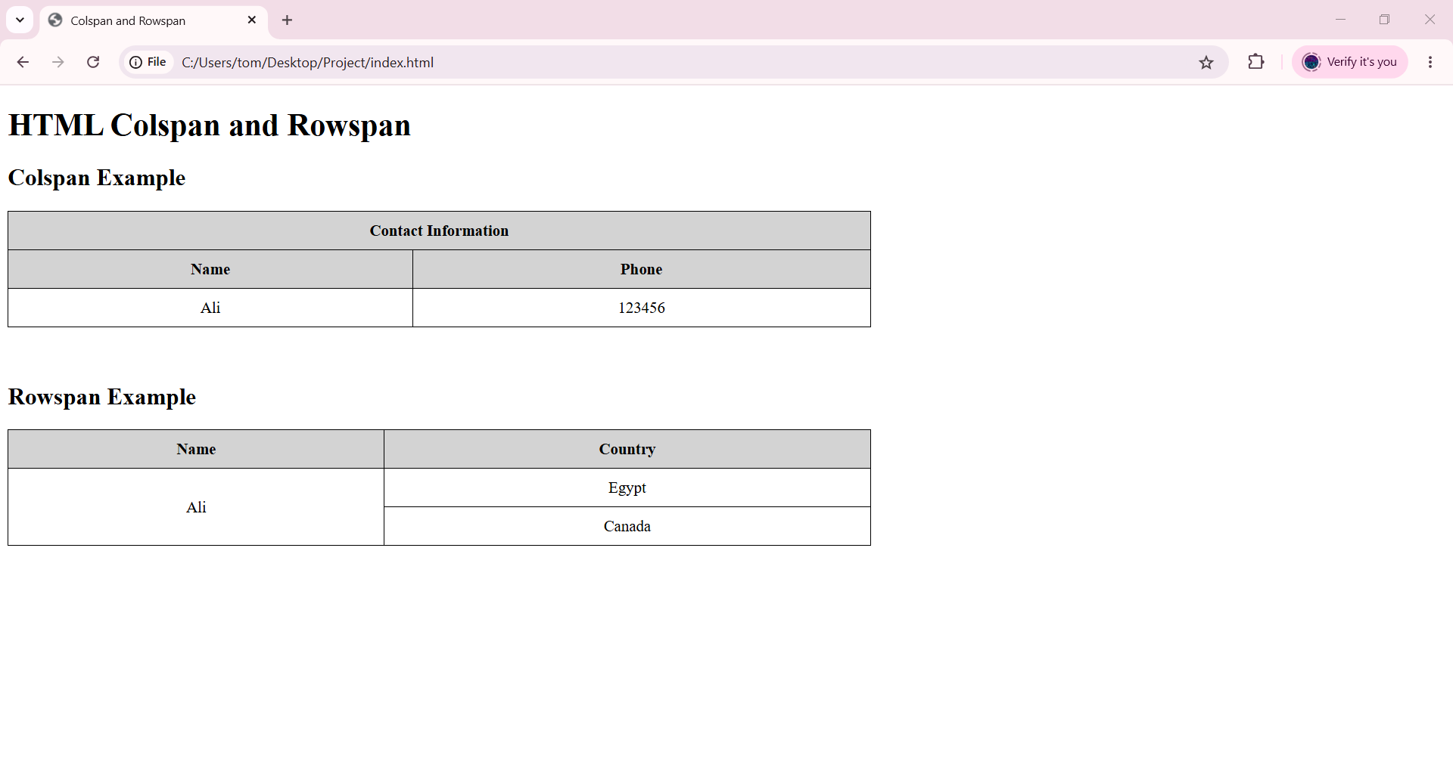

🧪 What You Can Test
# Source: AI Source: Provided by: [Data Path: Persons Table -> ID Column: 1, Name_En Column: Motasem Essam] -> From: [ChatGPT] on [5/6/2026]
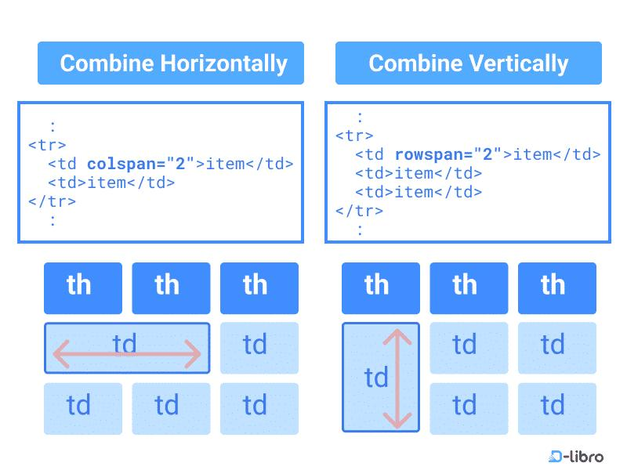
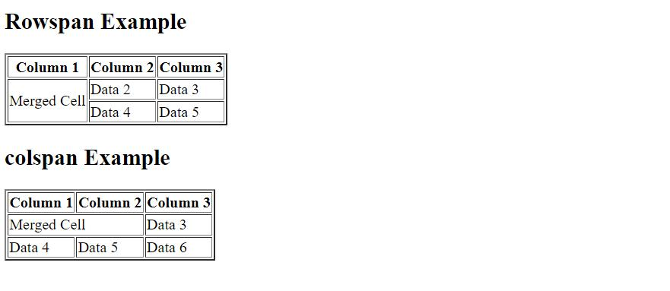
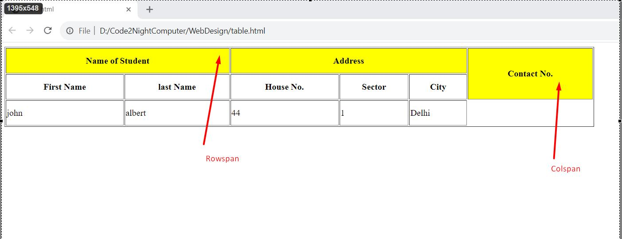
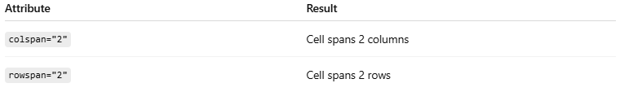
Attribute | Result
colspan="2" | Cell spans 2 columns
rowspan="2" | Cell spans 2 rows

⚠️ Important Notes

✅ colspan merges horizontally
# Source: AI Source: Provided by: [Data Path: Persons Table -> ID Column: 1, Name_En Column: Motasem Essam] -> From: [ChatGPT] on [5/6/2026]
👉 Across columns

✅ rowspan merges vertically
# Source: AI Source: Provided by: [Data Path: Persons Table -> ID Column: 1, Name_En Column: Motasem Essam] -> From: [ChatGPT] on [5/6/2026]
👉 Across rows

❌ Incorrect span values can break table layout
# Source: AI Source: Provided by: [Data Path: Persons Table -> ID Column: 1, Name_En Column: Motasem Essam] -> From: [ChatGPT] on [5/6/2026]
👉 Make sure row/column counts remain correct

🎨 HTML Table Styling
# Source: AI Source: Provided by: [Data Path: Persons Table -> ID Column: 1, Name_En Column: Motasem Essam] -> From: [ChatGPT] on [5/6/2026]
CSS table styling can add zebra stripes, hover effects, dividers, and alternating column colors for better table appearance and usability.
HTML tables can be styled using CSS to improve:
- readability
- appearance
- user interaction

🧠 Common Table Styling Features
# Source: AI Source: Provided by: [Data Path: Persons Table -> ID Column: 1, Name_En Column: Motasem Essam] -> From: [ChatGPT] on [5/6/2026]
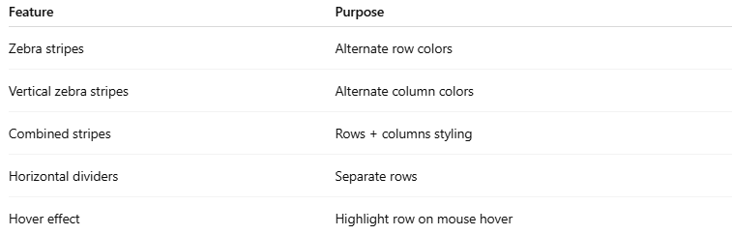
Feature | Purpose
Zebra stripes | Alternate row colors
Vertical zebra stripes | Alternate column colors
Combined stripes | Rows + columns styling
Horizontal dividers | Separate rows
Hover effect | Highlight row on mouse hover

1. 🦓 HTML Table — Zebra Stripes
# Source: AI Source: Provided by: [Data Path: Persons Table -> ID Column: 1, Name_En Column: Motasem Essam] -> From: [ChatGPT] on [5/6/2026]
📖 Description
Alternates row colors for better readability.
Usually done using:
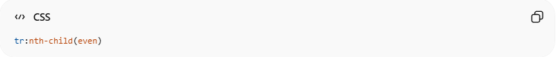
tr:nth-child(even)
💻 Example:
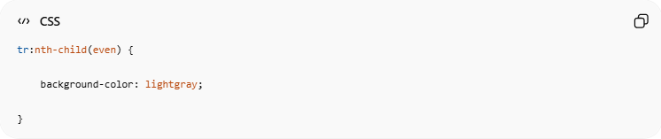
tr:nth-child(even) {
background-color: lightgray;
}
👉 Every even row gets color

2. ↕️ HTML Table — Vertical Zebra Stripes
# Source: AI Source: Provided by: [Data Path: Persons Table -> ID Column: 1, Name_En Column: Motasem Essam] -> From: [ChatGPT] on [5/6/2026]
📖 Description
Alternates column colors instead of rows.
Usually done using:
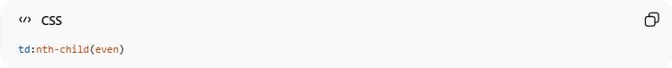
td:nth-child(even)
💻 Example:
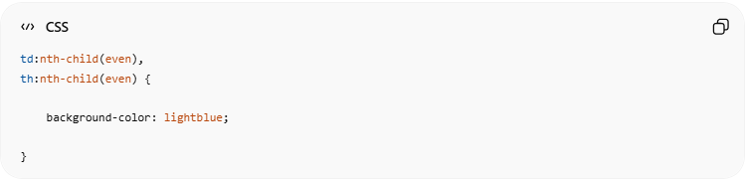
td:nth-child(even),
th:nth-child(even) {
background-color: lightblue;
}
👉 Every even column gets color

3. 🧩 Combine Vertical and Horizontal Zebra Stripes
# Source: AI Source: Provided by: [Data Path: Persons Table -> ID Column: 1, Name_En Column: Motasem Essam] -> From: [ChatGPT] on [5/6/2026]
📖 Description
Combines both:
- row stripes
- column stripes
for advanced styling.
💻 Example:
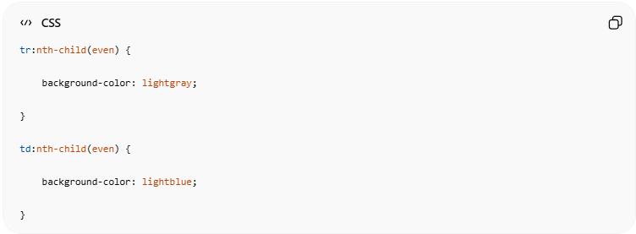
tr:nth-child(even) {
background-color: lightgray;
}
td:nth-child(even) {
background-color: lightblue;
}

4. ➖ Horizontal Dividers
# Source: AI Source: Provided by: [Data Path: Persons Table -> ID Column: 1, Name_En Column: Motasem Essam] -> From: [ChatGPT] on [5/6/2026]
📖 Description
Adds horizontal lines between rows.
💻 Example:
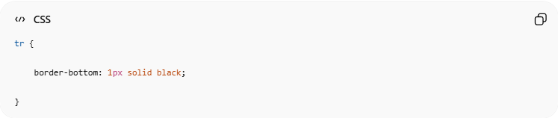
tr {
border-bottom: 1px solid black;
}
👉 Separates rows visually

5. ✨ Hoverable Table
# Source: AI Source: Provided by: [Data Path: Persons Table -> ID Column: 1, Name_En Column: Motasem Essam] -> From: [ChatGPT] on [5/6/2026]
📖 Description
Highlights table rows when the mouse moves over them.
💻 Example:
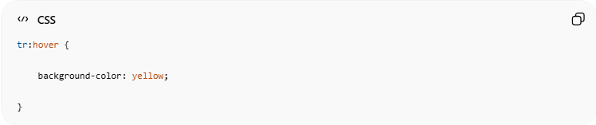
tr:hover {
background-color: yellow;
}
👉 Interactive hover effect

💻 Example

Full Example
# Source: AI Source: Provided by: [Data Path: Persons Table -> ID Column: 1, Name_En Column: Motasem Essam] -> From: [ChatGPT] on [5/6/2026]
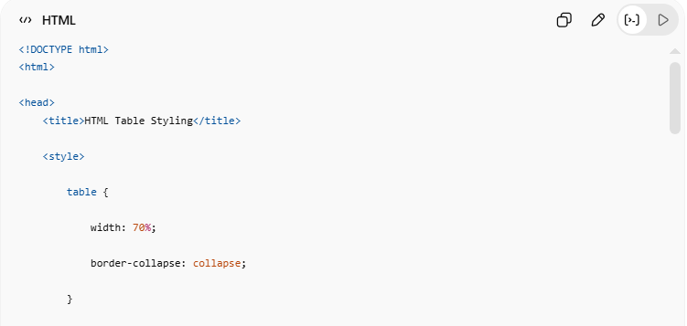
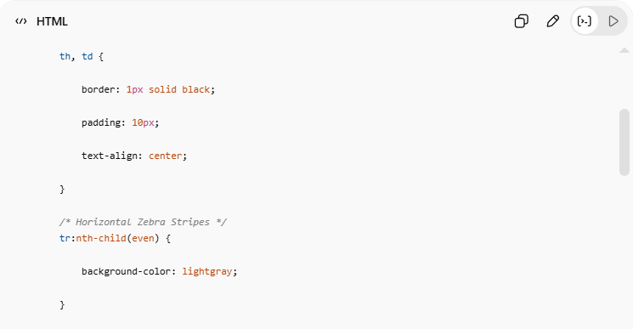
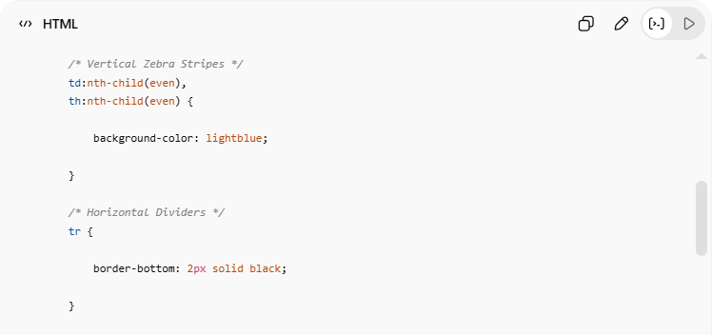
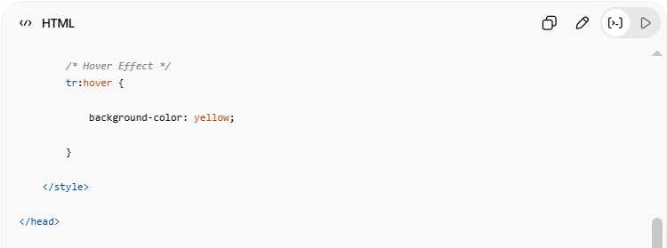
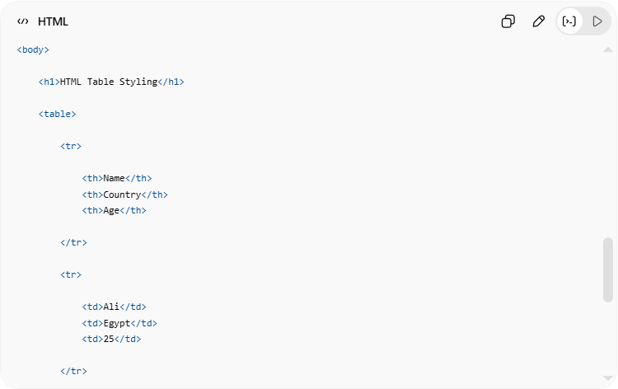
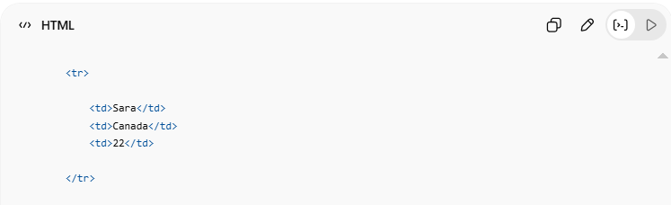
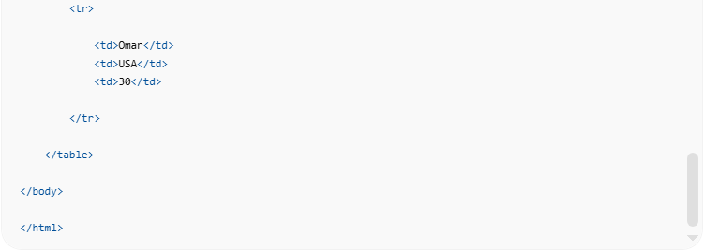
<!DOCTYPE html>
<html>
<head>
<title>HTML Table Styling</title>
<style>
table {
width: 70%;
border-collapse: collapse;
}
th, td {
border: 1px solid black;
padding: 10px;
text-align: center;
}
/* Horizontal Zebra Stripes */
tr:nth-child(even) {
background-color: lightgray;
}
/* Vertical Zebra Stripes */
td:nth-child(even),
th:nth-child(even) {
background-color: lightblue;
}
/* Horizontal Dividers */
tr {
border-bottom: 2px solid black;
}
/* Hover Effect */
tr:hover {
background-color: yellow;
}
</style>
</head>
<body>
<h1>HTML Table Styling</h1>
<table>
<tr>
<th>Name</th>
<th>Country</th>
<th>Age</th>
</tr>
<tr>
<td>Ali</td>
<td>Egypt</td>
<td>25</td>
</tr>
<tr>
<td>Sara</td>
<td>Canada</td>
<td>22</td>
</tr>
<tr>
<td>Omar</td>
<td>USA</td>
<td>30</td>
</tr>
</table>
</body>
</html>

Real Example
# Source: ScreenShot Source: Provided by: [Persons Table -> ID Column: 1, Name_En Column: Motasem Essam] -> Tool: [Automation Table -> ID Column: 16, Name_En Column: Screen Capture] -> From [Operating System: Windows] on [5/6/2026]
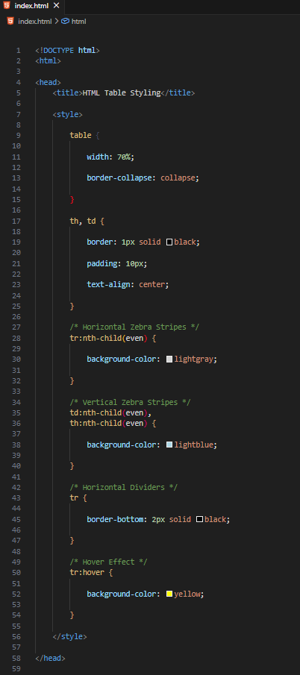
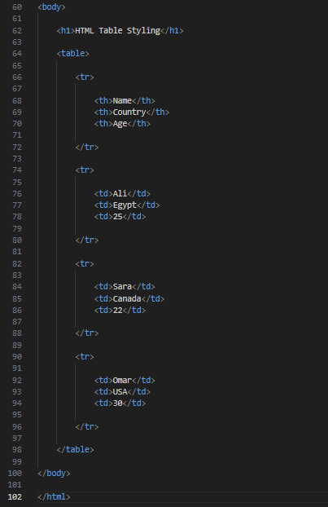
<!DOCTYPE html>
<html>

<head>
<title>HTML Table Styling</title>

<style>

table {

width: 70%;

border-collapse: collapse;

}

th, td {

border: 1px solid black;

padding: 10px;

text-align: center;

}

/* Horizontal Zebra Stripes */
tr:nth-child(even) {

background-color: lightgray;

}

/* Vertical Zebra Stripes */
td:nth-child(even),
th:nth-child(even) {

background-color: lightblue;

}

/* Horizontal Dividers */
tr {

border-bottom: 2px solid black;

}

/* Hover Effect */
tr:hover {

background-color: yellow;

}

</style>

</head>

<body>

<h1>HTML Table Styling</h1>

<table>

<tr>

<th>Name</th>
<th>Country</th>
<th>Age</th>

</tr>

<tr>

<td>Ali</td>
<td>Egypt</td>
<td>25</td>

</tr>

<tr>

<td>Sara</td>
<td>Canada</td>
<td>22</td>

</tr>

<tr>

<td>Omar</td>
<td>USA</td>
<td>30</td>

</tr>

</table>

</body>

</html>

# Source: GIF Source: Provided by: [Persons Table -> ID Column: 1, Name_En Column: Motasem Essam] -> Tool: [Automation Table -> ID Column: 17, Name_En Column: GIF Recorder] -> From [Operating System: Windows] on [5/6/2026]


🧪 What You Can Test
# Source: AI Source: Provided by: [Data Path: Persons Table -> ID Column: 1, Name_En Column: Motasem Essam] -> From: [ChatGPT] on [5/6/2026]
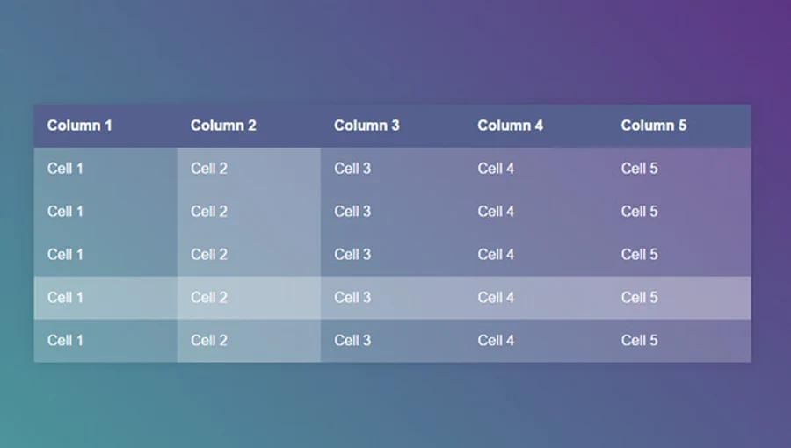
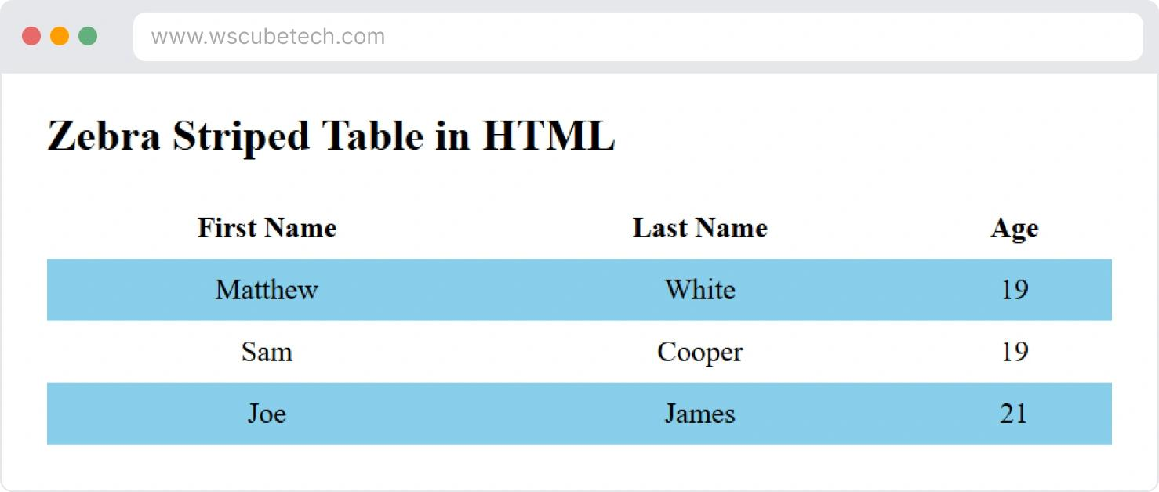
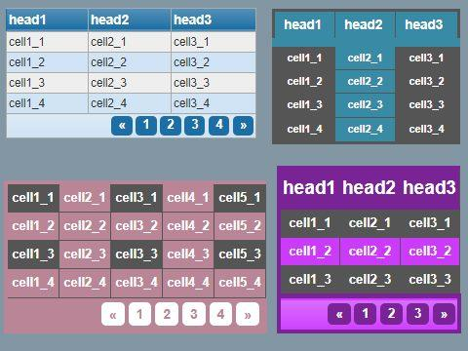
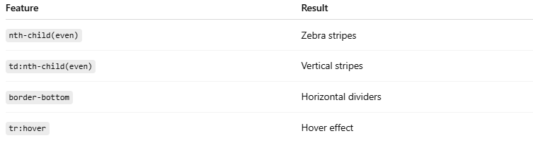
Feature | Result
nth-child(even) | Zebra stripes
td:nth-child(even) | Vertical stripes
border-bottom | Horizontal dividers
tr:hover | Hover effect

⚠️ Important Notes

✅ Zebra stripes improve readability
# Source: AI Source: Provided by: [Data Path: Persons Table -> ID Column: 1, Name_En Column: Motasem Essam] -> From: [ChatGPT] on [5/6/2026]
👉 Easier to read large tables

✅ Hover effects improve interaction
# Source: AI Source: Provided by: [Data Path: Persons Table -> ID Column: 1, Name_En Column: Motasem Essam] -> From: [ChatGPT] on [5/6/2026]
👉 Helps users focus on rows

❌ Avoid too many strong colors
# Source: AI Source: Provided by: [Data Path: Persons Table -> ID Column: 1, Name_En Column: Motasem Essam] -> From: [ChatGPT] on [5/6/2026]
👉 May reduce readability

📊 HTML Table <colgroup>
# Source: AI Source: Provided by: [Data Path: Persons Table -> ID Column: 1, Name_En Column: Motasem Essam] -> From: [ChatGPT] on [5/6/2026]
The HTML <colgroup> element is used to group and style one or more table columns.
It works together with:

<col>
👉 Useful for styling entire columns.

🧠 Main Elements
# Source: AI Source: Provided by: [Data Path: Persons Table -> ID Column: 1, Name_En Column: Motasem Essam] -> From: [ChatGPT] on [5/6/2026]
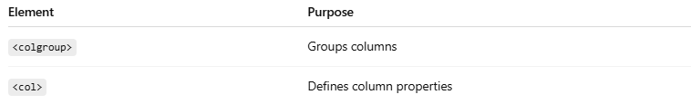
Element | Purpose
<colgroup> | Groups columns
<col> | Defines column properties

1. 📋 HTML Table <colgroup>
# Source: AI Source: Provided by: [Data Path: Persons Table -> ID Column: 1, Name_En Column: Motasem Essam] -> From: [ChatGPT] on [5/6/2026]
📖 Description
<colgroup> groups columns for styling or formatting.
💻 Example:
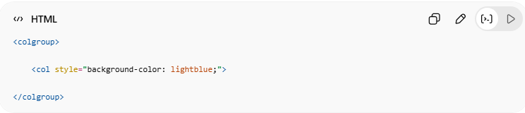
<colgroup>
<col style="background-color: lightblue;">
</colgroup>
👉 Styles the first column
🌐 Basic Structure
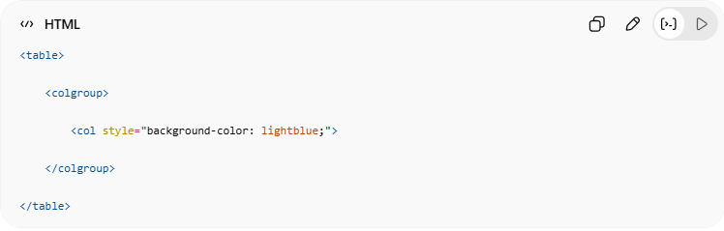
<table>
<colgroup>
<col style="background-color: lightblue;">
</colgroup>
</table>

2. ⚖️ Legal CSS Properties
# Source: AI Source: Provided by: [Data Path: Persons Table -> ID Column: 1, Name_En Column: Motasem Essam] -> From: [ChatGPT] on [5/6/2026]
📖 Description
Only some CSS properties work correctly with <col>.
✅ Common Supported Properties
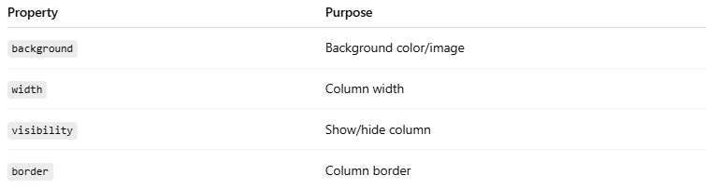
Property | Purpose
background | Background color/image
width | Column width
visibility | Show/hide column
border | Column border
💻 Example:
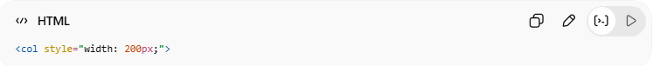
<col style="width: 200px;">

3. 🧩 Multiple <col> Elements
# Source: AI Source: Provided by: [Data Path: Persons Table -> ID Column: 1, Name_En Column: Motasem Essam] -> From: [ChatGPT] on [5/6/2026]
📖 Description
You can style multiple columns separately.
💻 Example:
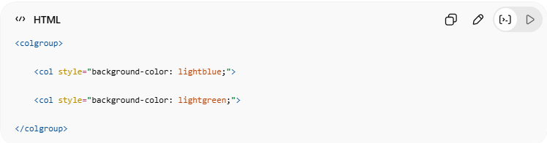
<colgroup>
<col style="background-color: lightblue;">
<col style="background-color: lightgreen;">
</colgroup>
👉 First and second columns get different colors

4. ⬜ Empty <colgroup>
# Source: AI Source: Provided by: [Data Path: Persons Table -> ID Column: 1, Name_En Column: Motasem Essam] -> From: [ChatGPT] on [5/6/2026]
📖 Description
<colgroup> can exist without styles.
💻 Example:
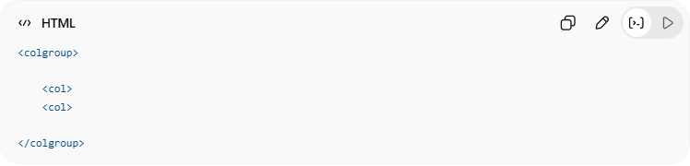
<colgroup>
<col>
<col>
</colgroup>
👉 Defines grouped columns without styling

5. 👻 Hide Columns
# Source: AI Source: Provided by: [Data Path: Persons Table -> ID Column: 1, Name_En Column: Motasem Essam] -> From: [ChatGPT] on [5/6/2026]
📖 Description
Columns can be hidden using:
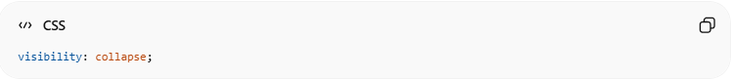
visibility: collapse;
💻 Example:
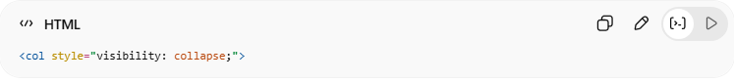
<col style="visibility: collapse;">
👉 Hides the column

💻 Example

Full Example
# Source: AI Source: Provided by: [Data Path: Persons Table -> ID Column: 1, Name_En Column: Motasem Essam] -> From: [ChatGPT] on [5/6/2026]
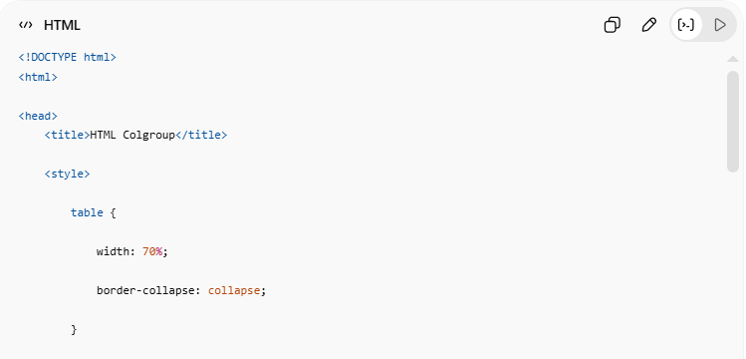
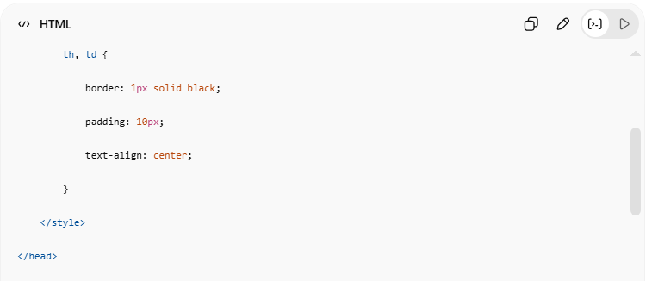
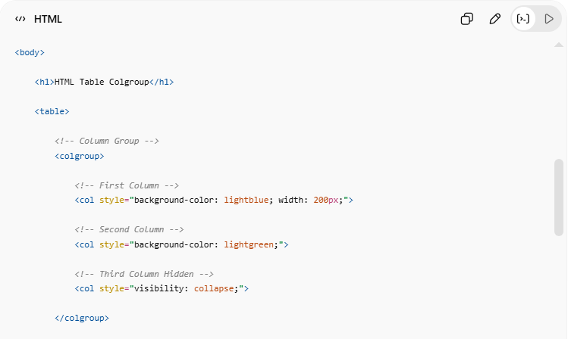
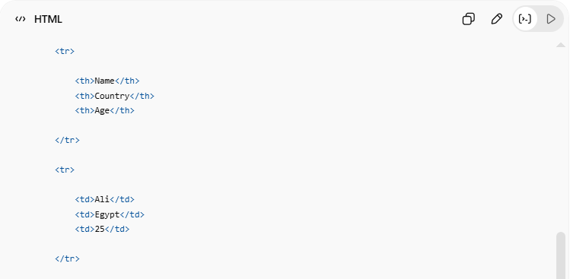
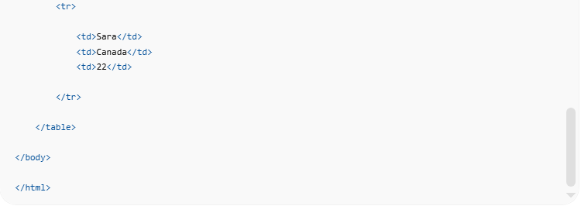
<!DOCTYPE html>
<html>
<head>
<title>HTML Colgroup</title>
<style>
table {
width: 70%;
border-collapse: collapse;
}
th, td {
border: 1px solid black;
padding: 10px;
text-align: center;
}
</style>
</head>
<body>
<h1>HTML Table Colgroup</h1>
<table>
<!-- Column Group -->
<colgroup>
<!-- First Column -->
<col style="background-color: lightblue; width: 200px;">
<!-- Second Column -->
<col style="background-color: lightgreen;">
<!-- Third Column Hidden -->
<col style="visibility: collapse;">
</colgroup>
<tr>
<th>Name</th>
<th>Country</th>
<th>Age</th>
</tr>
<tr>
<td>Ali</td>
<td>Egypt</td>
<td>25</td>
</tr>
<tr>
<td>Sara</td>
<td>Canada</td>
<td>22</td>
</tr>
</table>
</body>
</html>

Real Example
# Source: ScreenShot Source: Provided by: [Persons Table -> ID Column: 1, Name_En Column: Motasem Essam] -> Tool: [Automation Table -> ID Column: 16, Name_En Column: Screen Capture] -> From [Operating System: Windows] on [5/6/2026]
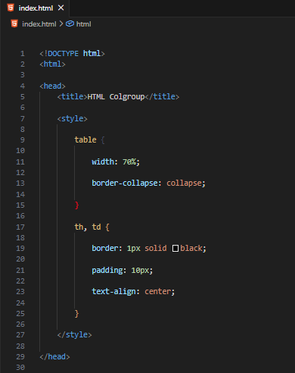
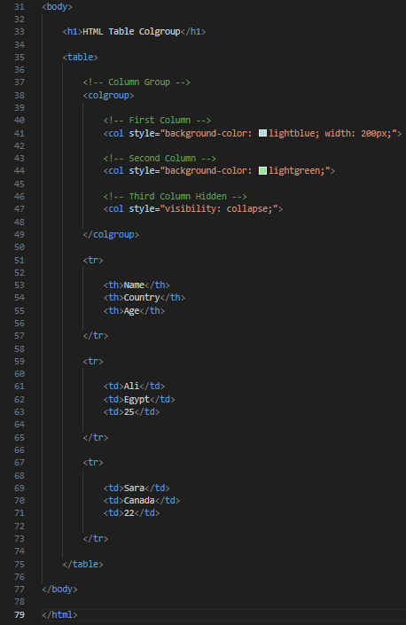
<!DOCTYPE html>
<html>

<head>
<title>HTML Colgroup</title>

<style>

table {

width: 70%;

border-collapse: collapse;

}

th, td {

border: 1px solid black;

padding: 10px;

text-align: center;

}

</style>

</head>

<body>

<h1>HTML Table Colgroup</h1>

<table>

<!-- Column Group -->
<colgroup>

<!-- First Column -->
<col style="background-color: lightblue; width: 200px;">

<!-- Second Column -->
<col style="background-color: lightgreen;">

<!-- Third Column Hidden -->
<col style="visibility: collapse;">

</colgroup>

<tr>

<th>Name</th>
<th>Country</th>
<th>Age</th>

</tr>

<tr>

<td>Ali</td>
<td>Egypt</td>
<td>25</td>

</tr>

<tr>

<td>Sara</td>
<td>Canada</td>
<td>22</td>

</tr>

</table>

</body>

</html>
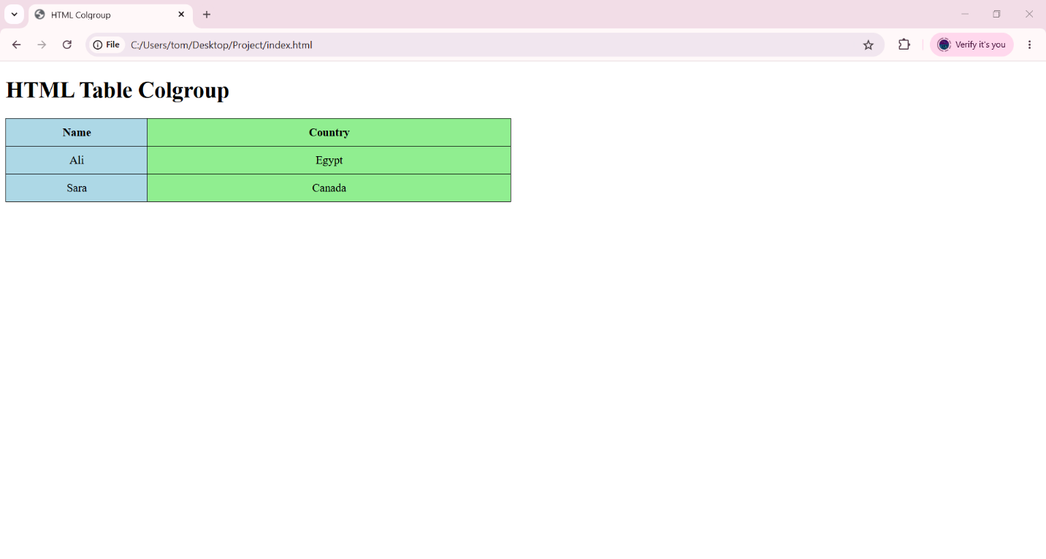

🧪 What You Can Test
# Source: AI Source: Provided by: [Data Path: Persons Table -> ID Column: 1, Name_En Column: Motasem Essam] -> From: [ChatGPT] on [5/6/2026]
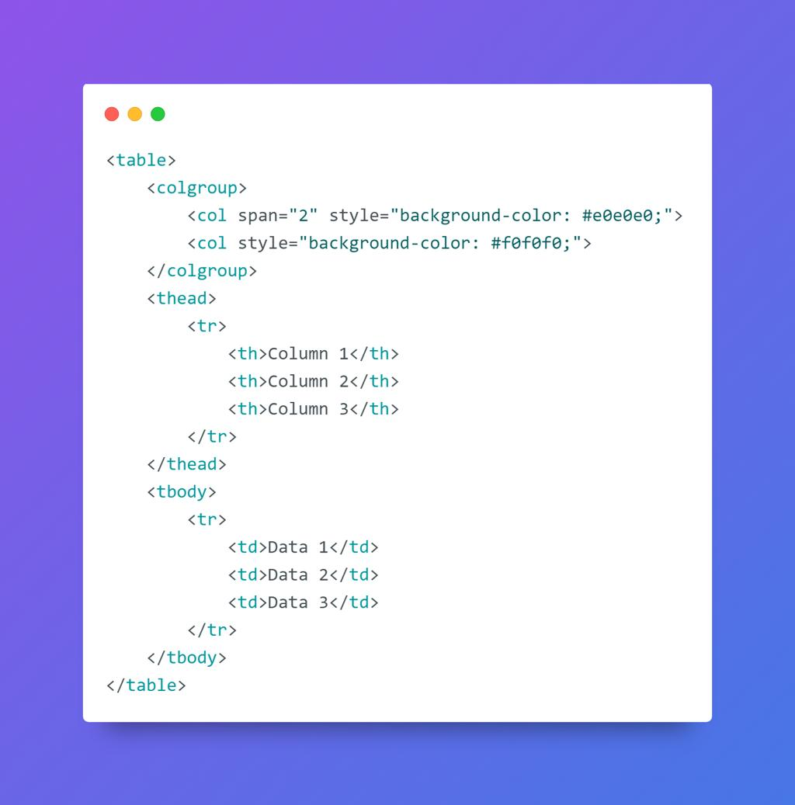
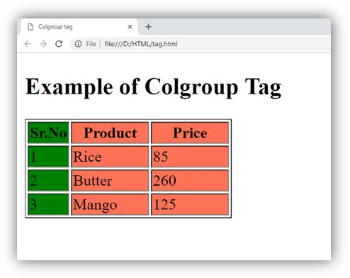
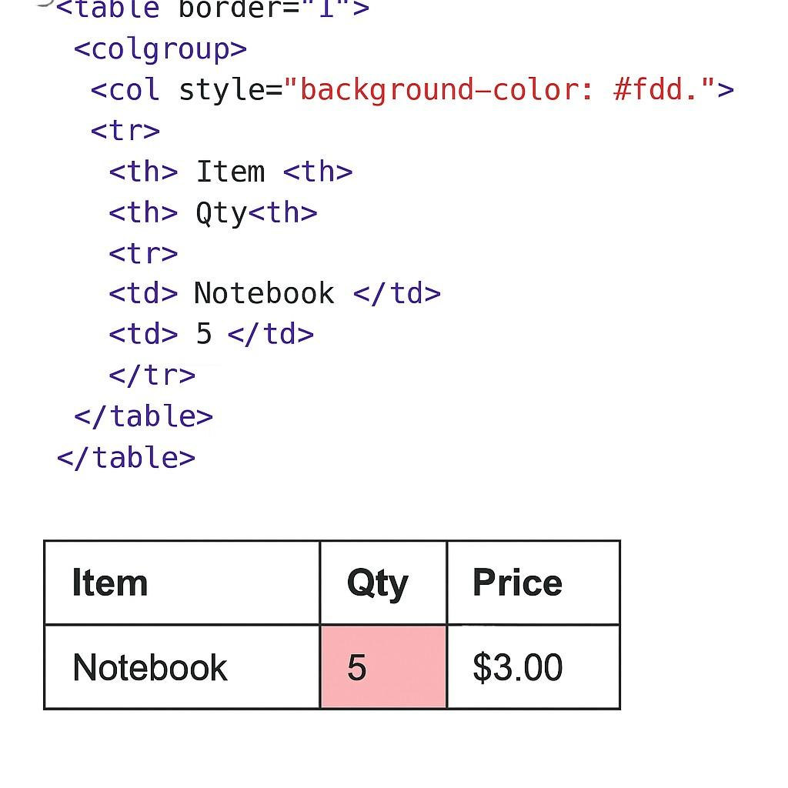
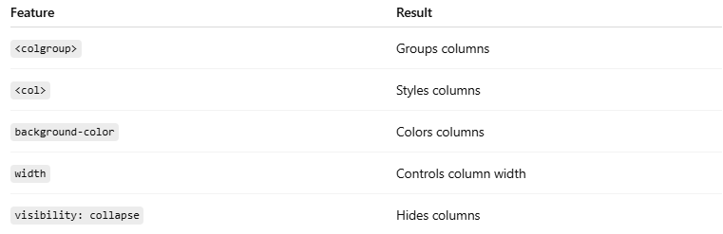
Feature | Result
<colgroup> | Groups columns
<col> | Styles columns
background-color | Colors columns
width | Controls column width
visibility: collapse | Hides columns

⚠️ Important Notes

✅ <colgroup> appears after <table>
# Source: AI Source: Provided by: [Data Path: Persons Table -> ID Column: 1, Name_En Column: Motasem Essam] -> From: [ChatGPT] on [5/6/2026]
👉 Before rows (<tr>)

✅ Useful for styling entire columns
# Source: AI Source: Provided by: [Data Path: Persons Table -> ID Column: 1, Name_En Column: Motasem Essam] -> From: [ChatGPT] on [5/6/2026]
👉 Cleaner than styling every cell

❌ Not all CSS properties work with <col>
# Source: AI Source: Provided by: [Data Path: Persons Table -> ID Column: 1, Name_En Column: Motasem Essam] -> From: [ChatGPT] on [5/6/2026]
👉 Mostly layout and visibility properties

🚀 In short:
# Source: AI Source: Provided by: [Data Path: Persons Table -> ID Column: 1, Name_En Column: Motasem Essam] -> From: [ChatGPT] on [5/6/2026]
<colgroup> and <col> are used to group, style, resize, and hide table columns efficiently.

⚠️ Important Notes

✅ Use <th> for headers
# Source: AI Source: Provided by: [Data Path: Persons Table -> ID Column: 1, Name_En Column: Motasem Essam] -> From: [ChatGPT] on [5/6/2026]
👉 Improves accessibility and readability

✅ Use border-collapse
# Source: AI Source: Provided by: [Data Path: Persons Table -> ID Column: 1, Name_En Column: Motasem Essam] -> From: [ChatGPT] on [5/6/2026]

border-collapse: collapse;
👉 Merges table borders cleanly

✅ Use semantic table sections
# Source: AI Source: Provided by: [Data Path: Persons Table -> ID Column: 1, Name_En Column: Motasem Essam] -> From: [ChatGPT] on [5/6/2026]
👉 Better structure and organization

❌ Avoid tables for webpage layout
# Source: AI Source: Provided by: [Data Path: Persons Table -> ID Column: 1, Name_En Column: Motasem Essam] -> From: [ChatGPT] on [5/6/2026]
👉 Modern layouts use:
- CSS Flexbox
- CSS Grid
instead of tables

🚀 In short:
# Source: AI Source: Provided by: [Data Path: Persons Table -> ID Column: 1, Name_En Column: Motasem Essam] -> From: [ChatGPT] on [5/6/2026]
HTML tables organize structured data using rows, columns, headers, and semantic table sections like <thead>, <tbody>, and <tfoot>.

